Dear Parent / Carer,

Ty Gwyn were accredited Silver Rights Aware Award with Unicef UK last summer!

Ty Gwyn is a school where children’s rights are at the heart of our ethos and culture, to improve well-being and to develop every child’s talents and abilities to their full potential.

Unicef is the world’s leading organisation working for children and young people and their rights. In 1989, governments across the world agreed that all children have the same rights by adopting the UN Convention on the Rights of the Child (UNCRC). These rights are based on what a child needs to survive, grow, participate and fulfil their potential. For further information about Rights Respecting Schools please visit: www.unicef.org.uk/rrsa

Ty Gwyn pupils learn about their rights every day and we really hope that you will be able to support our school on our journey towards becoming a Unicef UK Rights Respecting Gold School.

We have created a ‘wants and needs’ game for you to engage with your child/children if appropriate. These games will introduce children and young people to their rights by helping them to consider the difference between a WANT and a NEED.

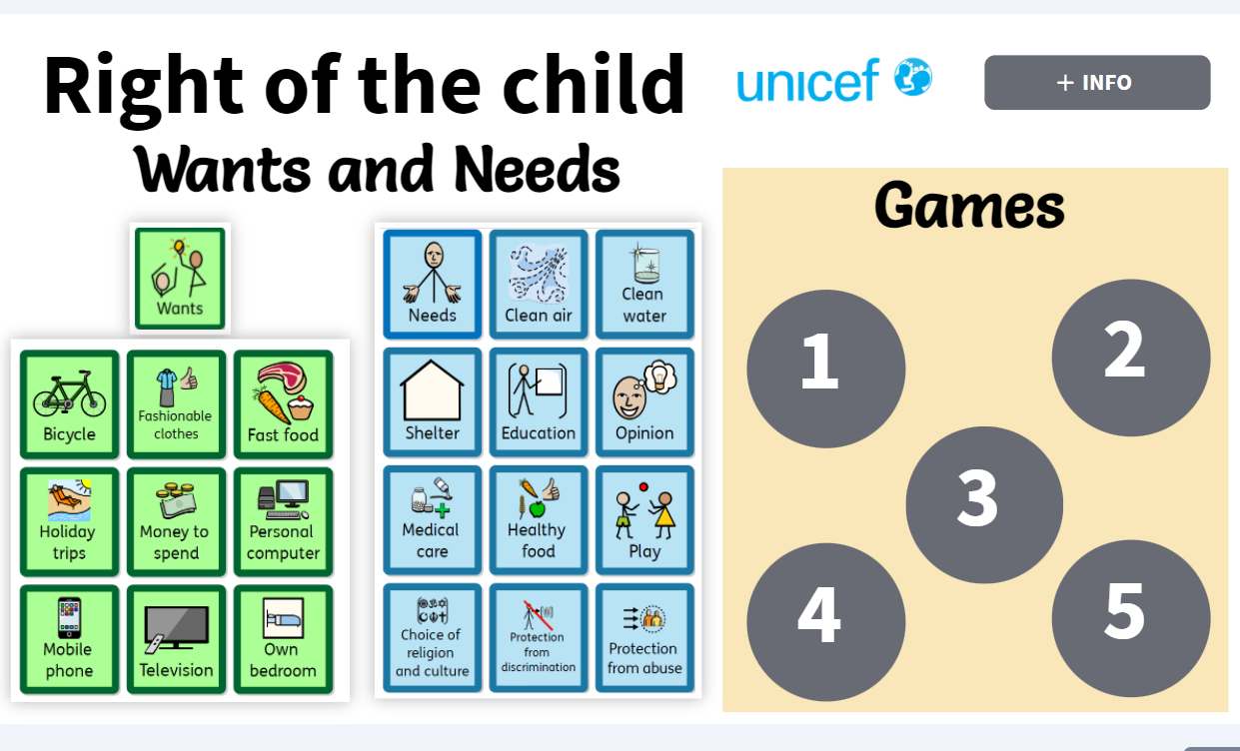
Scan the QR Code or use the following link
https://view.genial.ly/616583b089def70dfbd7ea23/interactive-content-right-respecting

Yours sincerely,

Diane Stones
Head of School

