These signs are for use on an appropriate part of the body in order to aid communication for children who may not be able to see traditional signs (i.e. visual impairment) or have limited physical movements themselves.

Ensure you ask permission first or already have a trust relationship with the child before using these on-body signs.

For more detailed information or if more signs are needed please use the following website link;

<http://www.ssc.education.ed.ac.uk/canaanbarrie/>

# Canaan

# Barrie

**On-Body**

**Signs**

## Goodbye

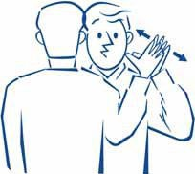

Touch fingertips of child and wave.

## Hello

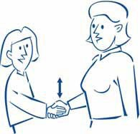

Shake right hand of child

## Up/Stand up

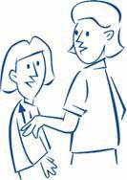

Rub hand up child’s upper arm then flick fingers against thumb, up high

## Down/Sit down

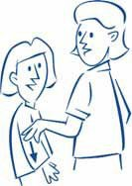

Rub hand down child’s upper arm, then flick fingers

against thumb, down low

## Good

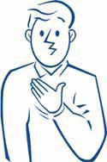

A “positive” sign, tap your chest twice with flat hand.

Also: like/want/happy

### Don’t want/

don’t like

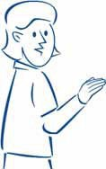

A “negative” sign, child pushes own hand away from body, or adult gently pushes on child’s shoulder

## Finished

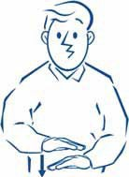

Tap flat hand on back of other hand twice with palms facing downward towards floor

## Again

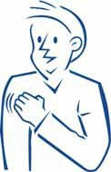

Tap fist twice on opposite upper arm

## More Massage

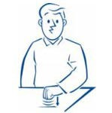 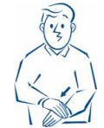

Tap fist down twice Rub back of hand with palm of other hand twice

## Home

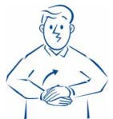

Clasp one hand over the back of the other then bring both towards chest and tap chest once