Ice Painting

Ice painting is a great art activity for babies and toddlers, as well as older kids.  It’s process driven and a great way of exploring colours. Little children will love the sensory experience of touching and investigating freezing and melting ice too.

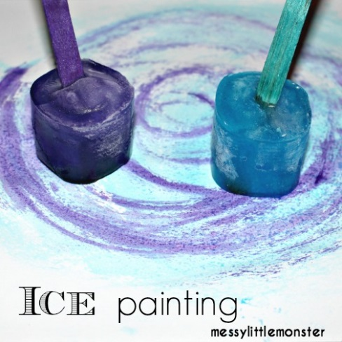

To make the ice paint sticks I filled small yoghurt pots with water and then mixed in a tiny bit of gel food colouring.  I put a lollipop in each pot and put them in the freezer. I left them overnight to freeze but a couple of hours should be plenty of time.

Once the ice had frozen I took the ice paint sticks out of the yoghurt pots and we were ready to get painting.

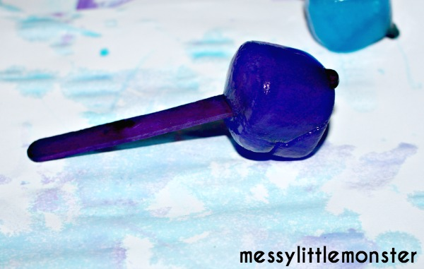

The ice paints made some really effective watery patterns.

