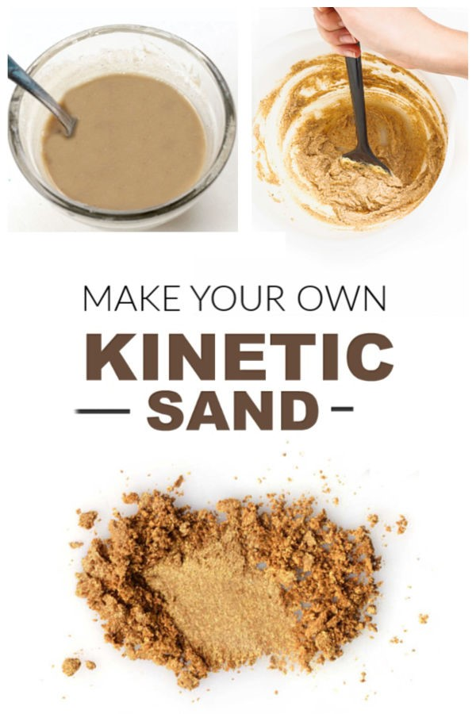

**Kinetic Sand Recipe**

* 1 cup of [play sand](https://amzn.to/2Q6XNF2)
* 1/2 tbsp [corn starch](https://amzn.to/2FnzWwG)
* 1 tsp [dish soap](https://amzn.to/2qOHOgE)
* 1 cup of water *(added as needed).*

*The dish soap in this recipe is what gives this sand a kinetic-like quality.  It is so fun to squish and form into shapes in your hands.*

**Method**

* Begin by combining the play sand and corn starch in a large bin or container.
* Mix well.
* In a separate container combine 1 cup of water with 1 tsp of dish soap and stir until the water is bubbly.
* Then, slowly add the water-mixture to the sand/cornstarch and mix well.

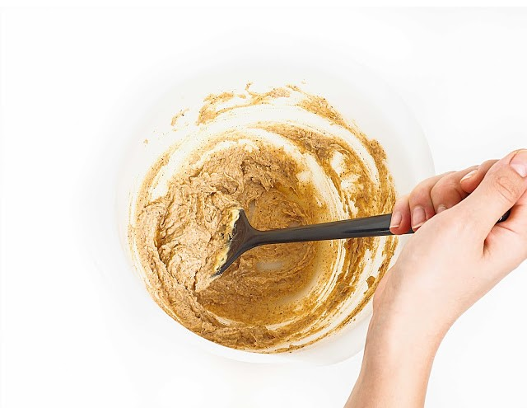

* Mix and mix, slowly adding more water & mixing as you go.

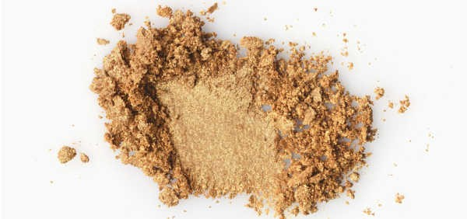

* Continue to add more water & mix until the desired consistency is reached.



That's it!  Easy, right?  And so fun!