Rainbow Pasta

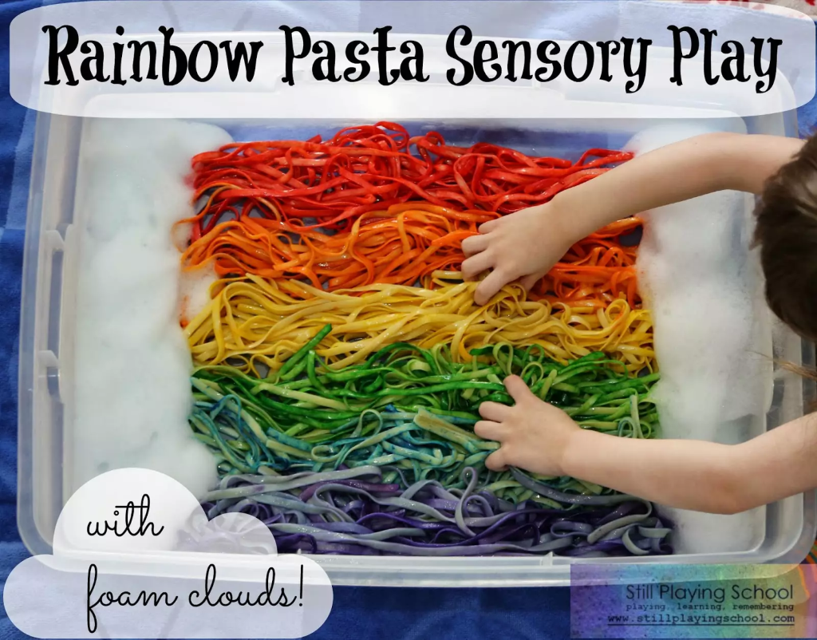
Boil a huge batch of long noodles - fettuccine or spaghetti work well.
Rinse with cool water, and dye with food colouring.
Add a little cooking oil so the pasta does not get too sticky.
Throw the pasta into a plastic tray, then let kids get messy swirling and twirling it through their fingers.
Practice arranging the noodles in rainbow order by using seven different shades.

