Pringle puppets

You need:

1 Pringle pot or similar ( no lid required)

1 piece of dowling rod or similar approx. 60cms long

Plain coloured card/paper or Duck tape

Glue gun or elastic bands (to attach toy to dowling)

Small wooden brick with hole in it or soft fabric to use as handle (see photos)

Small favourite toy

Instructions

1. Remove the lid, it’s not needed. Cover the outside and base of the tube using Ducktape or coloured card and a glue stick.

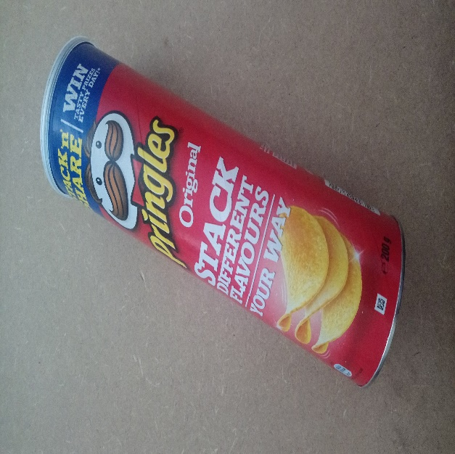 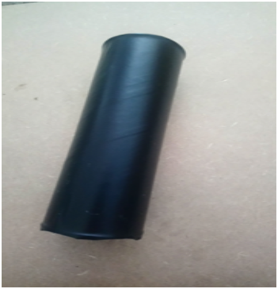

1. Try to cover about 5cms inside the tube top.

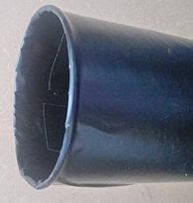

1. Make a hole through the bottom of the tube and push the dowling rod through.

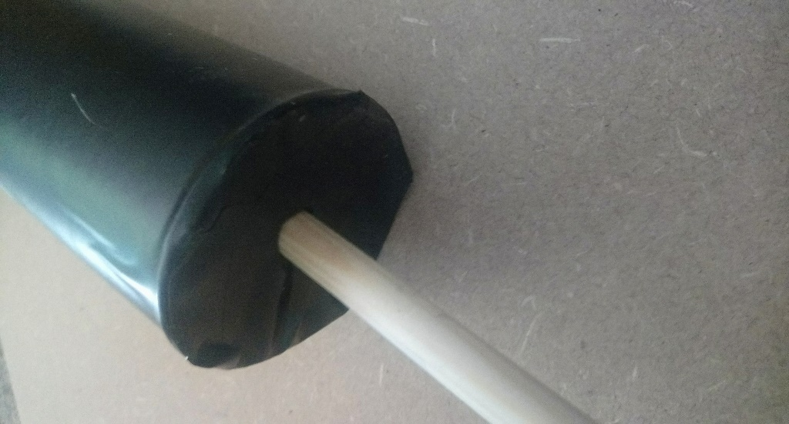

1. Attach a small wooden brick with a hole in it or wind some soft fabric around the bottom end and secure with tape or glue. (this makes it easier to hold)

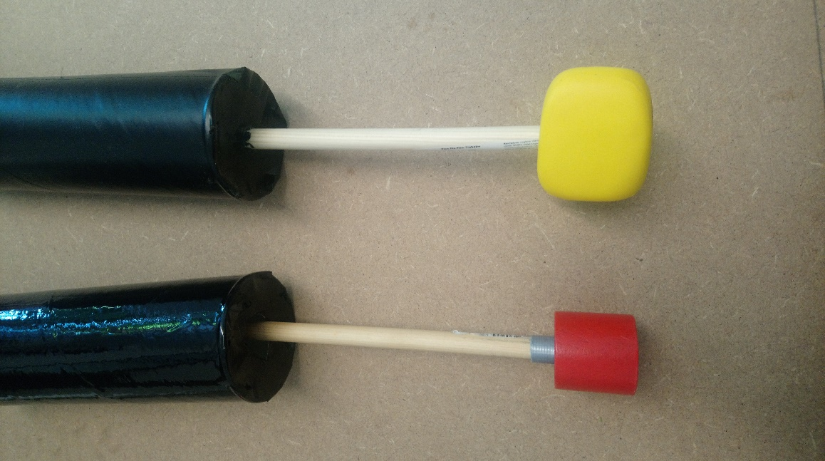

1. Where the dowling rod pokes through the top of the tube, use a glue gun, tape or elastic bands to attach a favourite toy securely. ( ensure its small enough to pull in and out of the tube first!

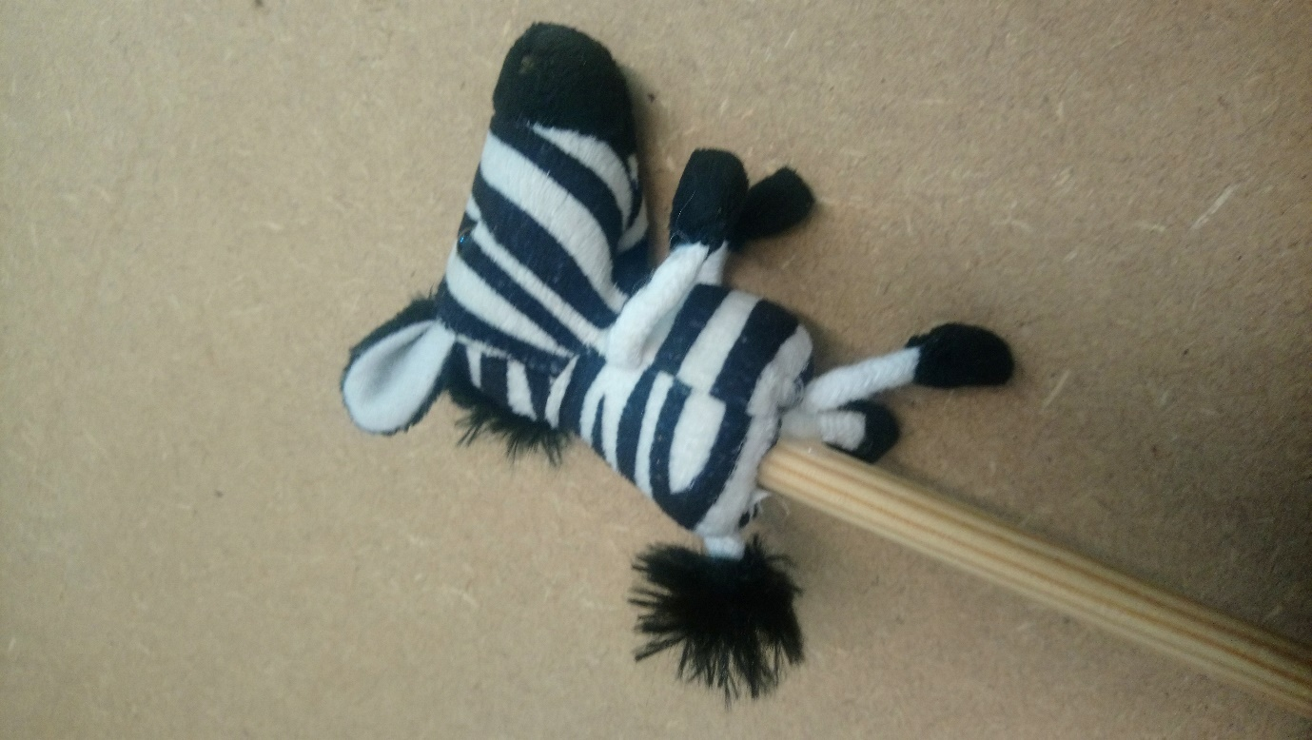

1. Pull the puppet down into the tube until it is hidden from sight.
2. Hold the tube a short distance from the child and slowly push the puppet out.

Lots of talking , sounds, watching, looking, stories and fun.

You can make more than one pringle puppet and watch your child enjoy the show!

