Personal books

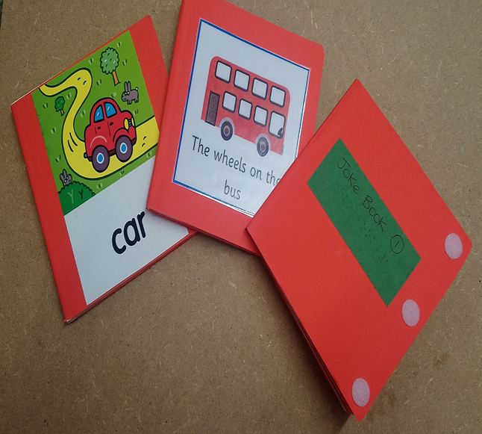

You need:

Any book with cardboard pages.

Coloured card or paper

Glue stick

Scissors

Instructions

1. Put the coloured paper onto a flat surface and place the book on top so that it fits neatly into the corner of the paper.

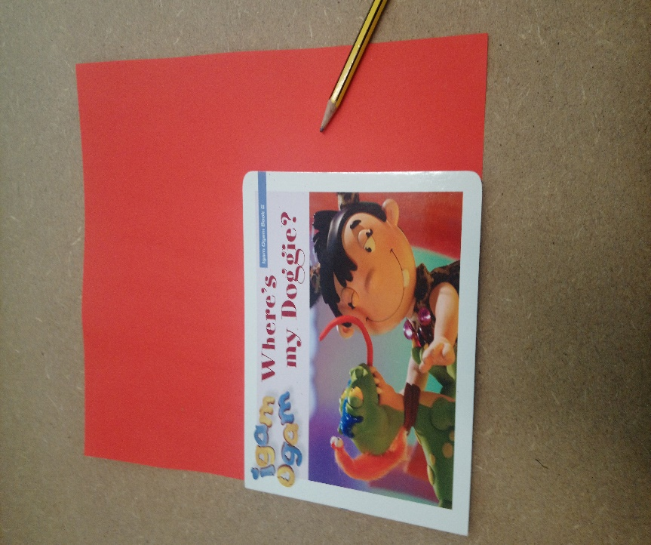

1. Using a sharp pencil draw neatly around the book and cut out the shape. Leave a little extra around the edges when you cut, this makes fitting it to the book much easier.
2. Count the number of pages inside the book plus the back cover page and cut out the same number of card shapes. Leave the front cover for later.

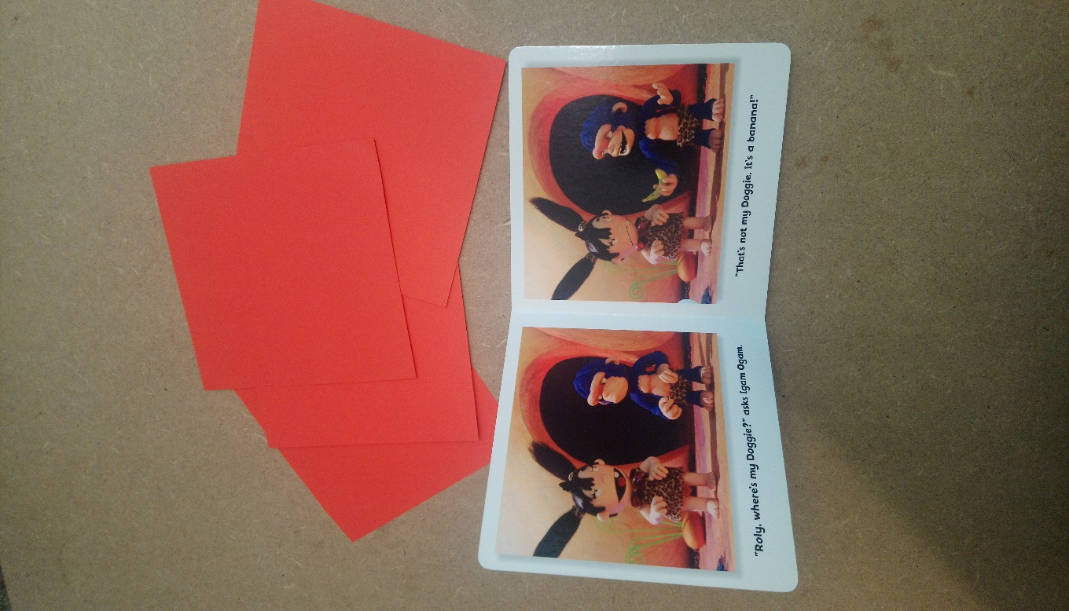

1. Using a glue stick, cover one page with glue and carefully place the new card on top.
2. It helps if you leave a small gap between the fold of the book and the page itself. (This makes the book close properly) You may need to move the new card a couple of times to make it fit. It takes a bit of practice.

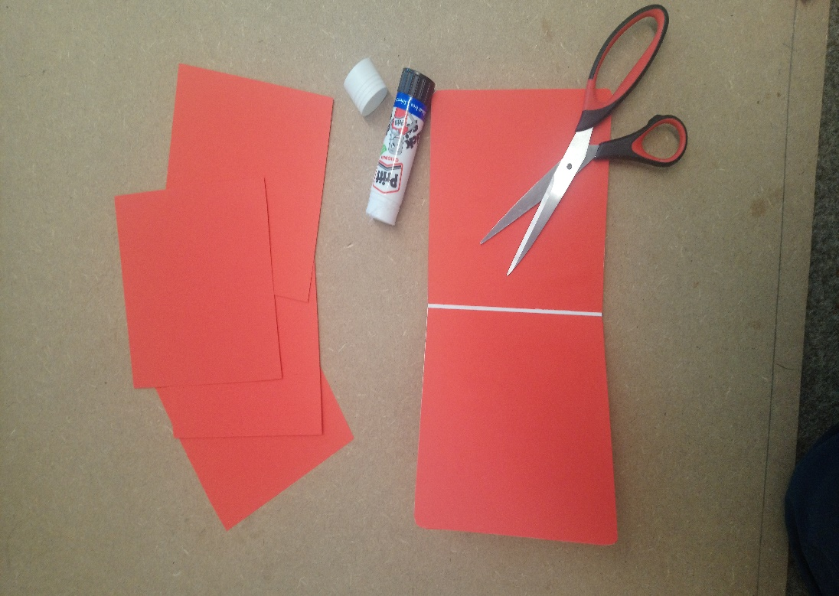

6. Smooth the surface of the page and cut around the edges of the book where the card overlaps. Best to do this with each page before you move on to the next.

7. To cover the book. First cover the back as normal. Next cut around the front cover leaving an extra 3cms at the centre seam edge.

Glue the front cover onto the book and wrap the extra 3cms over the back cover.

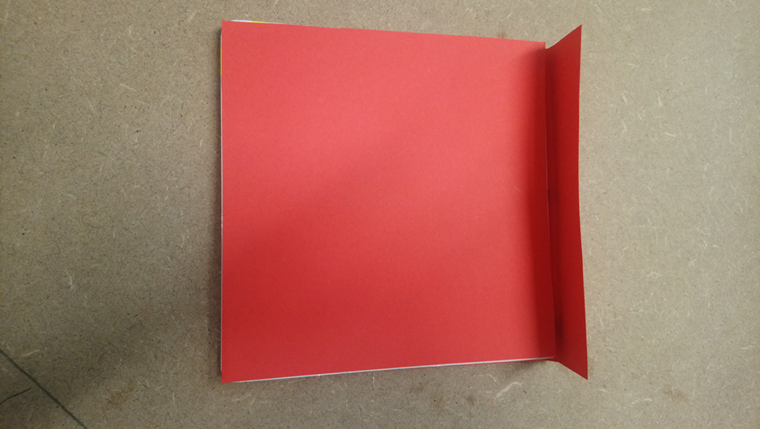

8. Glue well and hold in place or put another book on top until the glue is dry. (This makes a neat edge).

For extra help to identify each book, textured fabric could be glued along the spine or on to the front cover.

Make a selection of new books.

You can add family photos, letters, numbers, make up your own stories together putting the child’s name in every page.

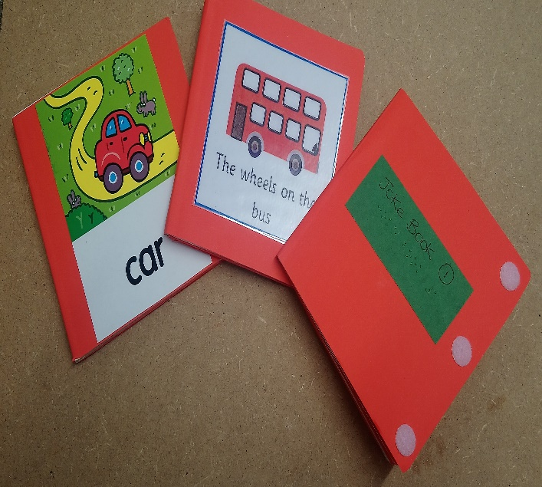

Lots of fun for everyone and creates a lovely memory book.

Here are some more examples, if you want to make a tactile book. In this example, children can go on a car journey and feel apples, trees, grass, fish, clouds and ducks!

