Flying paper plate owls!

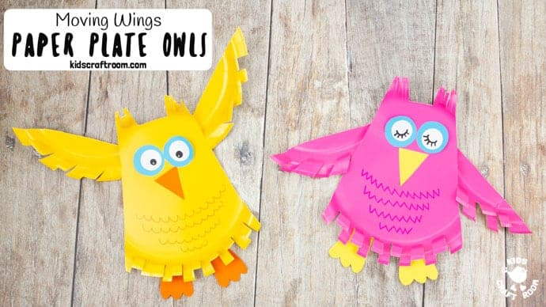

1. 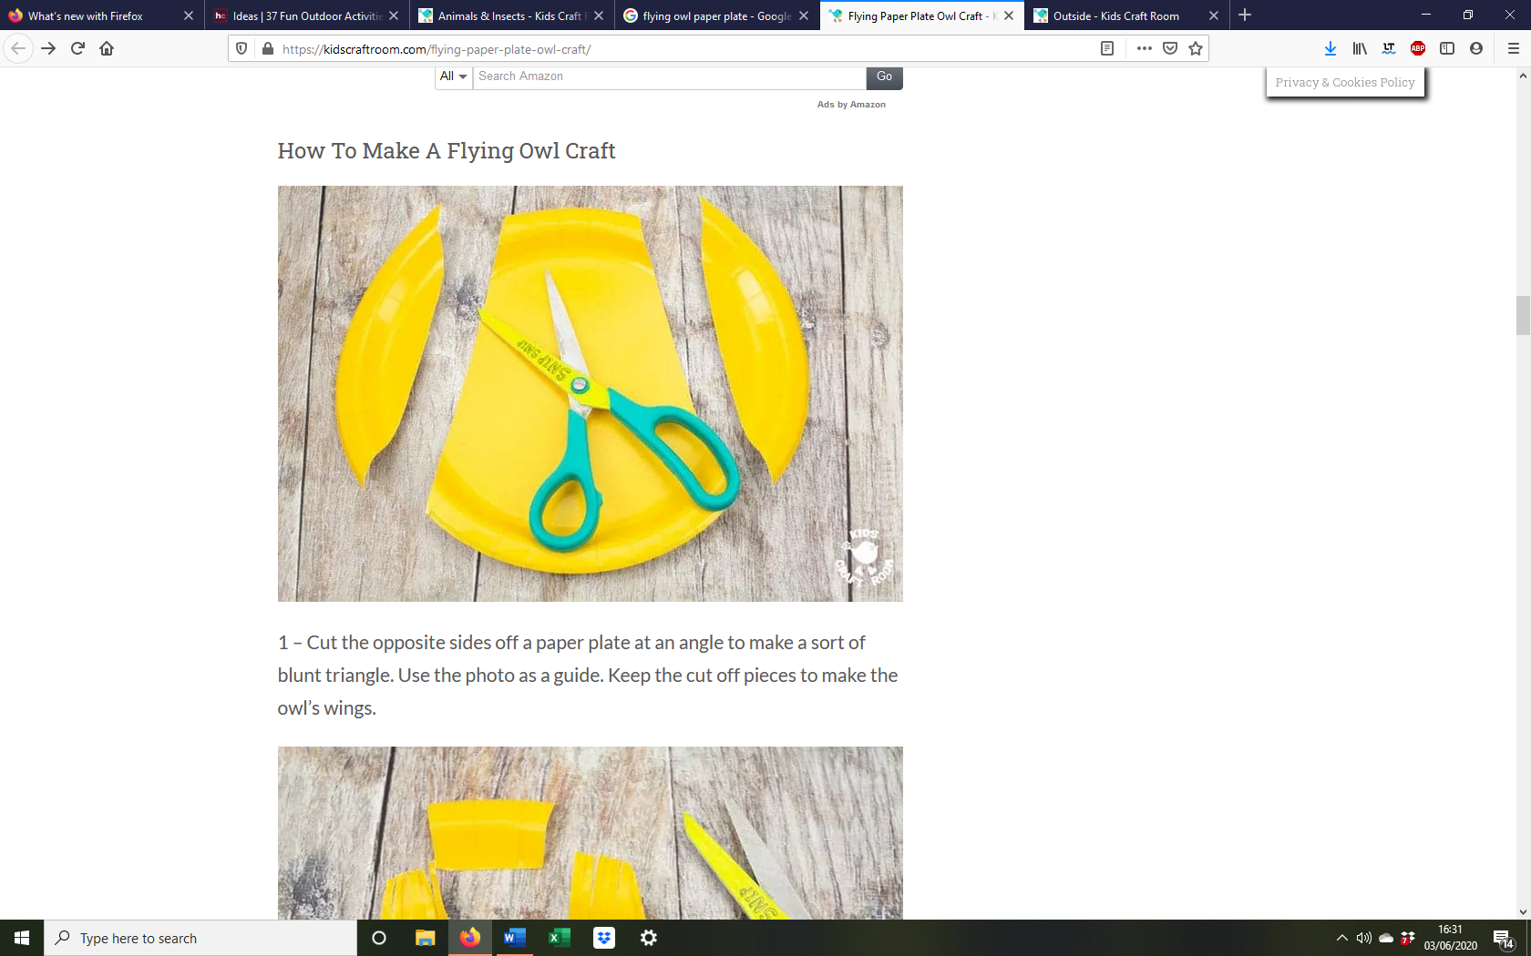Cut the opposite sides off a paper plate at an angle to make a sort of blunt triangle. Use the photo as a guide. Keep the cut off pieces to make the owl’s wings.
2. At the top of your triangle cut out a rectangle to leave two ears. Snip into the ears to make them tufty and feathery.

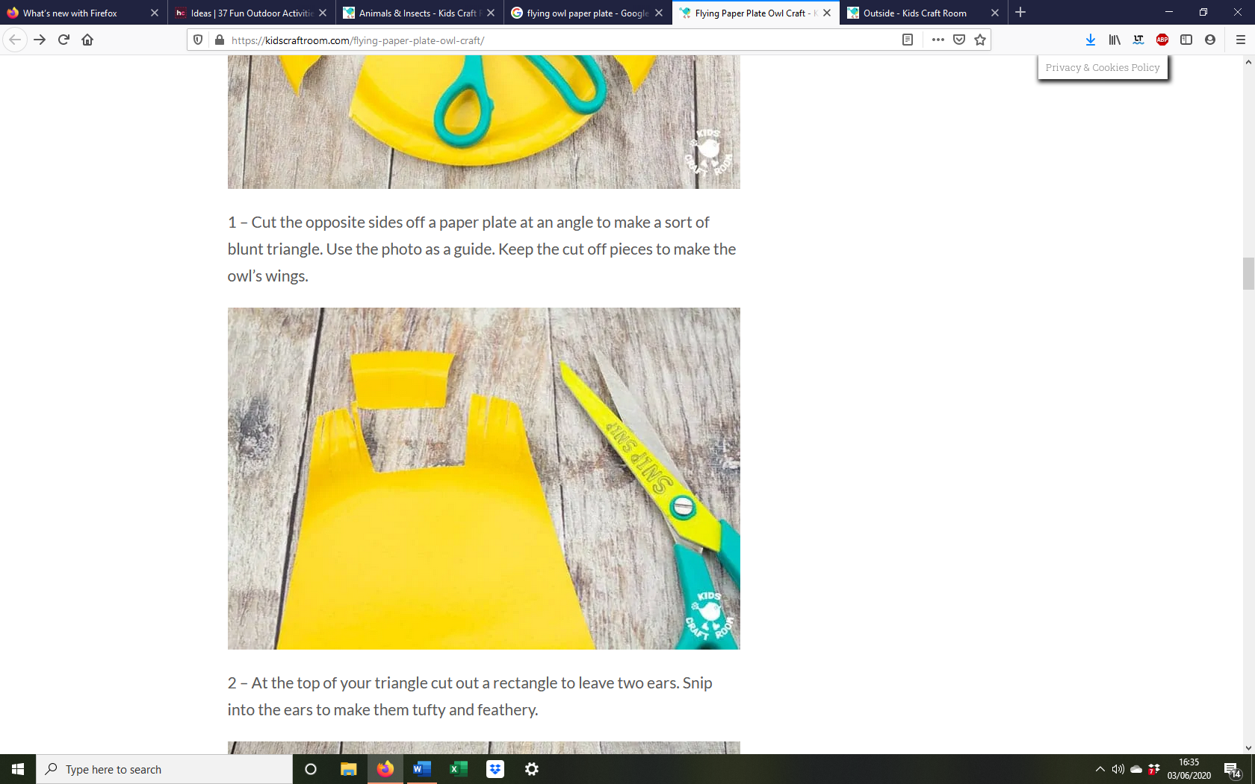

1. Give your paper plate owl craft a lovely feathery effect by cutting short snips along the bottom of the owl’s tummy and the curves edges of the wings. 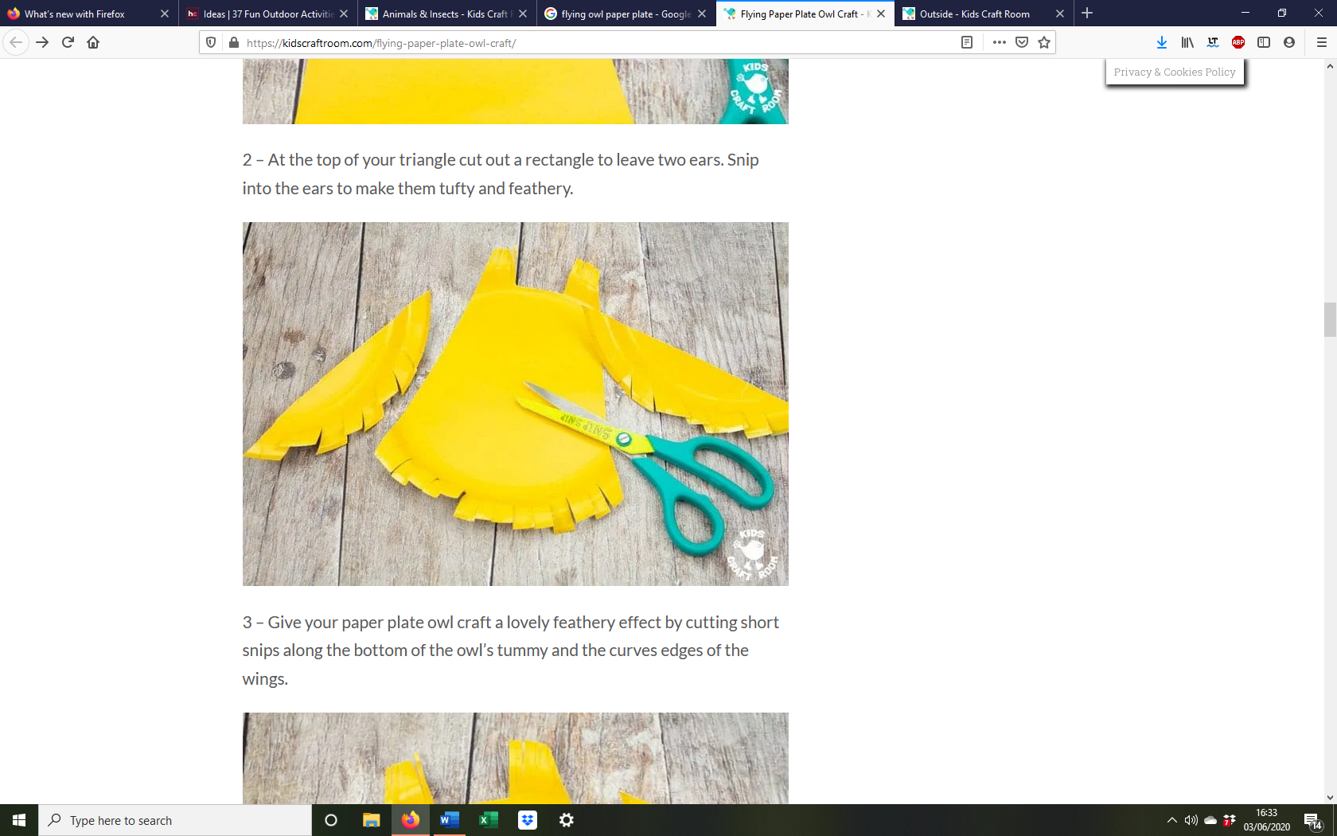
2. 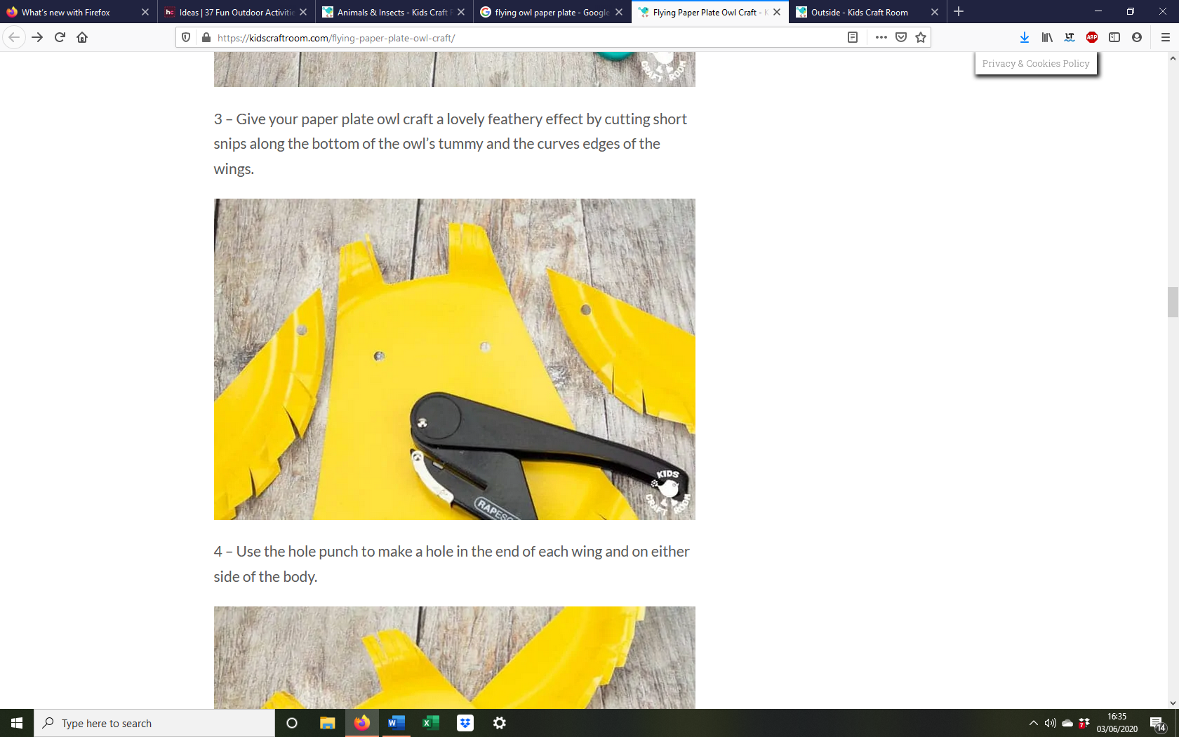Use the hole punch to make a hole in the end of each wing and on either side of the body.
3. Secure the wings to the owl’s body with split pins/paper fasteners.

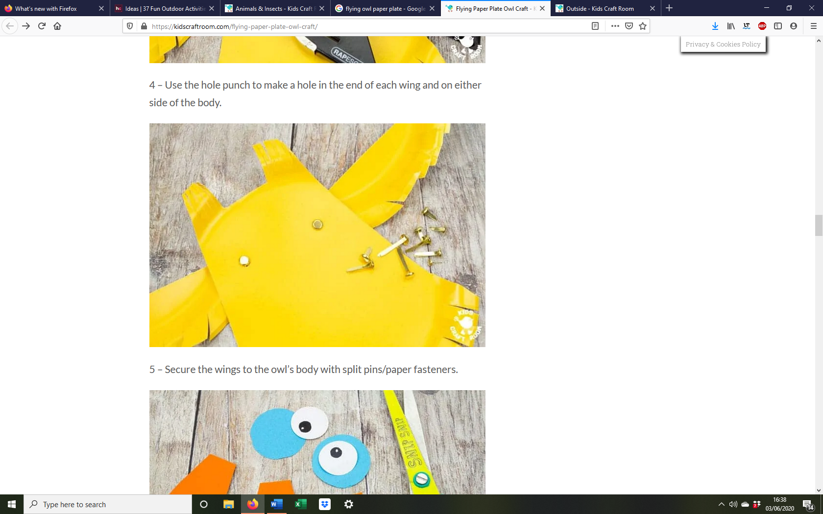

1. Use your paper scraps to cut two large round owl eyes, a beak and two feet. 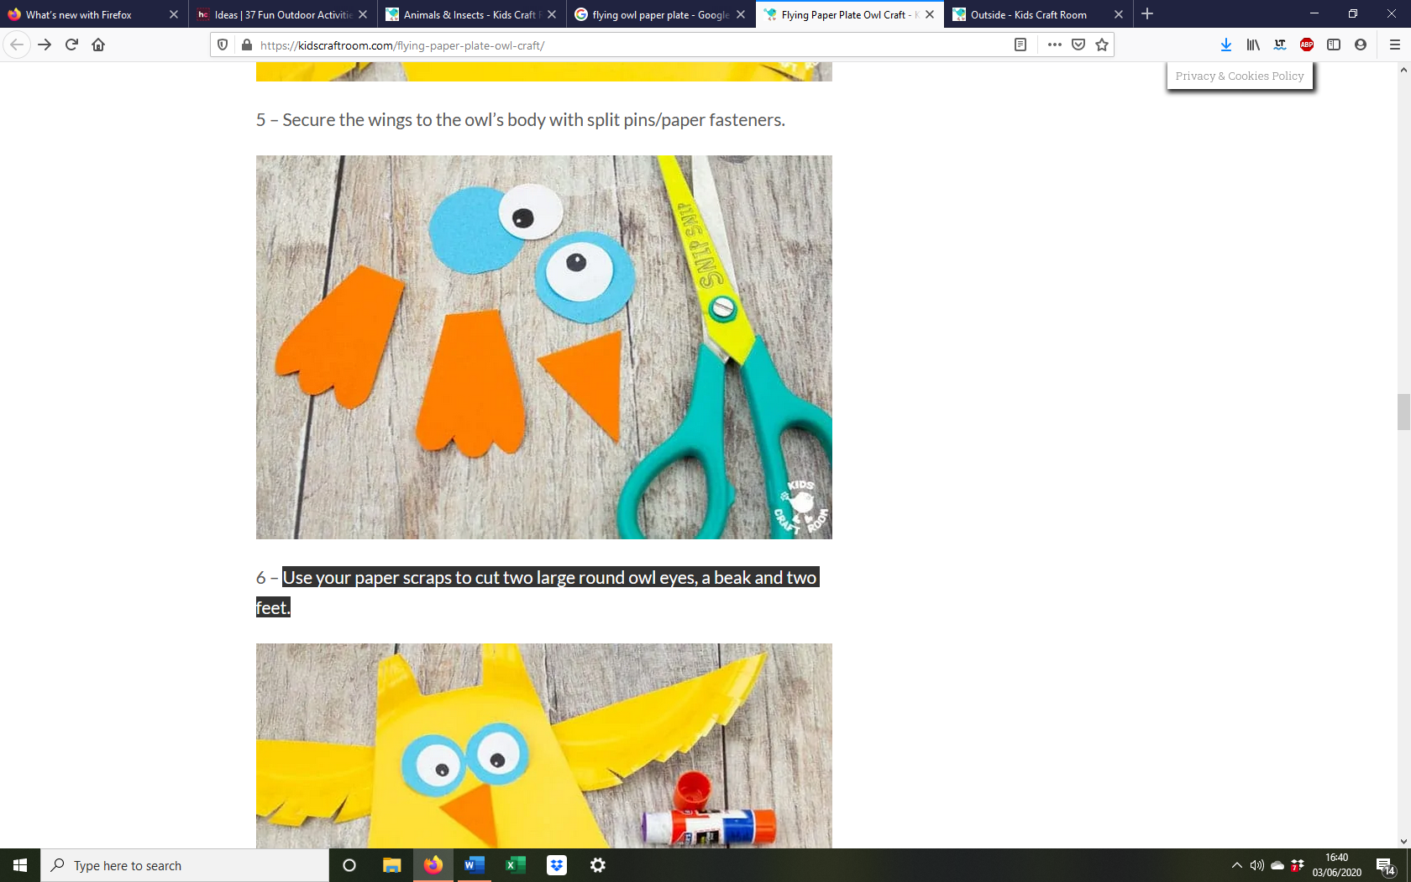
2. Glue the features onto the front of your owl.
3. Now your Flying Owl Craft is ready to take for the skies or have a little snooze!

