**Handprint Snowflakes**

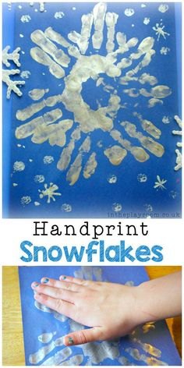

**You will need:**

Blue Card

Silver or white paint

Paint brush

Glitter

**How to make:**

1. Paint your child’s hand using silver or white paint
2. Help your child to print their hand onto the blue card. Make at least 6 prints, with these prints going around in a circle to make a snowflake.
3. Decorate with glitter if you wish!