**Fine Motor Activities**

What better way to help your child develop and strengthen their fine motor skills than through play, and, even better, using household items!

**1) Push pom-poms into a plastic container / Place coins in the slit of a plastic container -** You can use real coins or fake ones (the coins from Connect Four work well) and almost any type of container that is clean and empty — an old container of baby food, cream cheese, margarine, salsa … anything!

[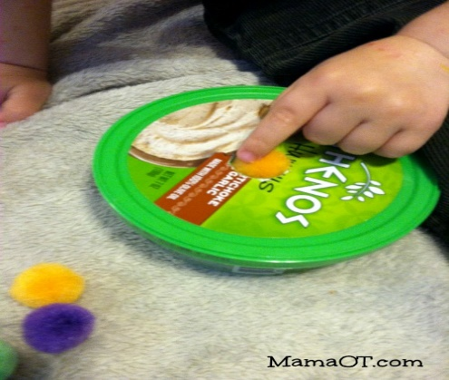](http://mamaot.com/wp-content/uploads/2014/03/image_31-text.jpg)[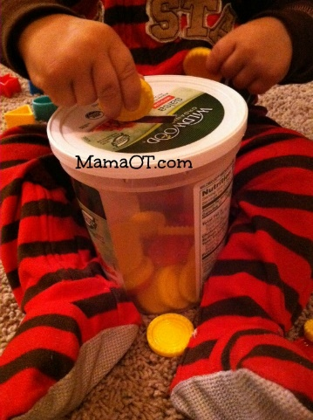](http://mamaot.com/wp-content/uploads/2014/05/image_32-text.jpg)

**2) Pinch toothpicks and drop them in the holes of a spice container or cut Q-tips in half and drop them in a Tic-Tac container.**

**[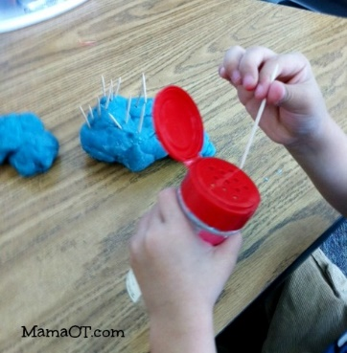](http://mamaot.com/wp-content/uploads/2014/04/Toothpicks-in-bottle-text.jpg)** 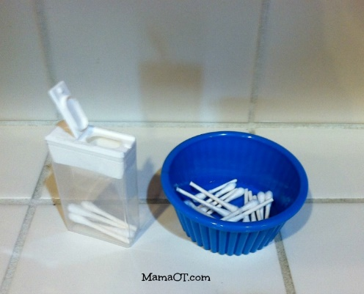

**3) Pour small items back and forth between containers -** You can use dry rice, pasta, or even pebbles from outside. These types of solid materials provide additional auditory feedback as they go *clink! clink! clink!* from one container to the other.

[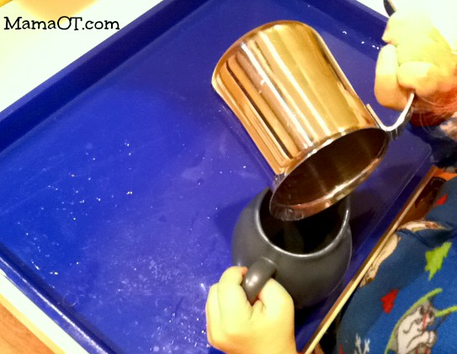](http://mamaot.com/wp-content/uploads/2014/03/image_7-text.jpg)

**4) Paint with sponge shapes -** Cut up a kitchen sponge into whatever shapes you want, then show your child how to dip them in paint and use them as stamps.

**5)** **Push beads into play dough -** Pretend you’re making cookies and the beads are chocolate chips, or hide the beads in the play dough and search for hidden treasure as you exercise those finger muscles!

[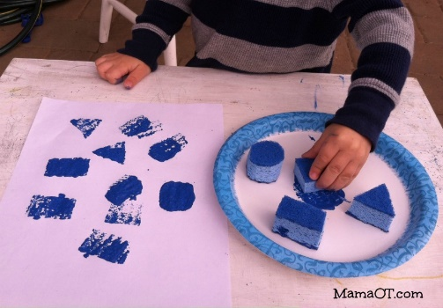](http://mamaot.com/wp-content/uploads/2014/03/image_8-text.jpg) [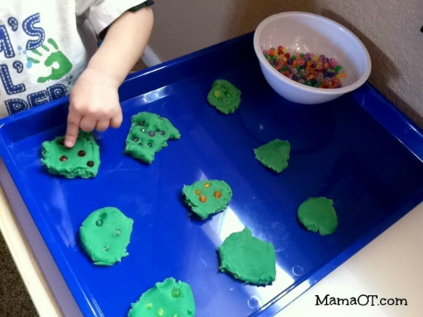](http://mamaot.com/wp-content/uploads/2014/03/image_10-text1.jpg)

**6) Make shapes in play dough with cookie cutters -** Flatten the dough, push down the shapes, and pinch to pull up out of the dough. So much fine motor power!

**7) Smash play dough with a potato smasher** – Or smash some real potatoes. Or bananas!

**[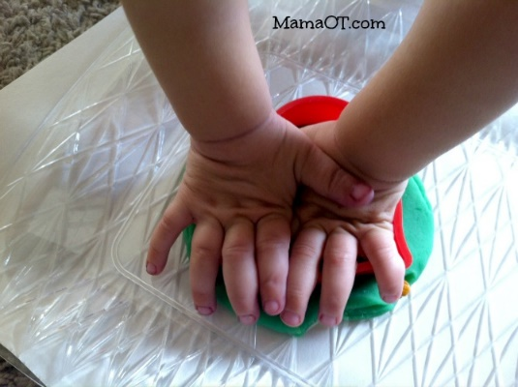](http://mamaot.com/wp-content/uploads/2014/03/image_12-text1.jpg) [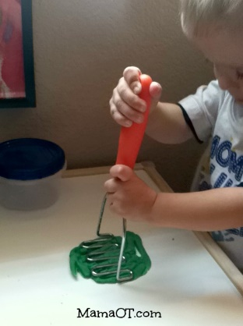](http://mamaot.com/wp-content/uploads/2014/03/image_9-text1.jpg)**

**8) Squeeze food clips onto the rim of a plastic container -** Then take them off. Then put them back on again. Then take them off. And so on and so forth. You’d be surprised at how time consuming this activity can be!

**9) Put pipe cleaners in the holes of a colander -** Another incredibly simple yet repetitive and engaging activity!

[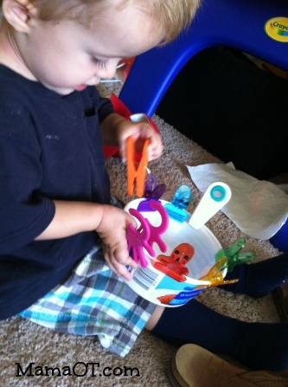](http://mamaot.com/wp-content/uploads/2014/05/image_17-text.jpg) [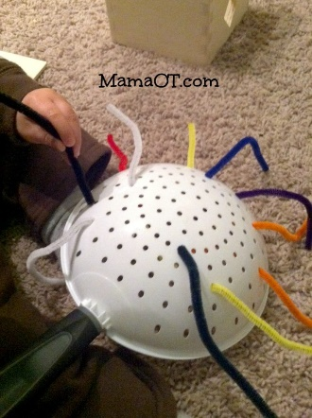](http://mamaot.com/wp-content/uploads/2014/05/image_20-text.jpg)

**10) Put Cheerios on pipe cleaners -** This is a great skill for older toddlers to start practicing, and is safer for the little ones who still want to put real beads in their mouths. Shoelaces work well too if you don’t have any pipe cleaners.

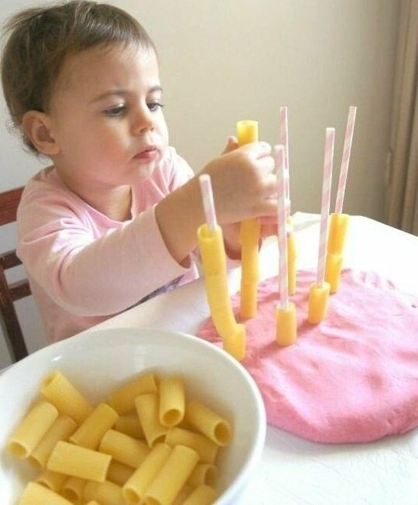**11) Stack beads on dry spaghetti -** It can actually be pretty tricky to put the beads on without breaking the noodles! Use Cheerios if you’re worried about beads going into mouths! Even stack dry pasta onto straws!

[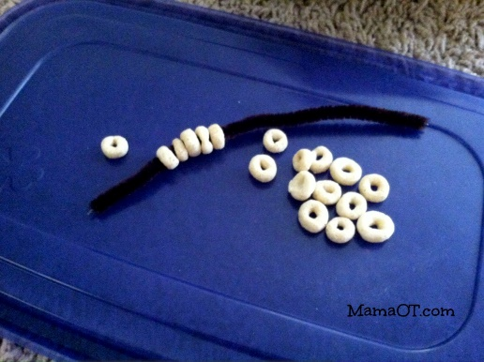](http://mamaot.com/wp-content/uploads/2014/05/image_21-text.jpg) [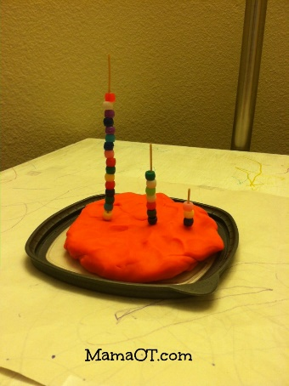](http://mamaot.com/wp-content/uploads/2014/05/image_28-text.jpg)

**12) Bend a straw in half and use it as tongs for crumpled napkin bits -** Especially useful when trying to entertain your kids while waiting for your food at a restaurant!

**13) Peel fruit.** Did you ever think about this as a fine motor activity? It is! Those tiny tangerines are perfect for chubby little hands.

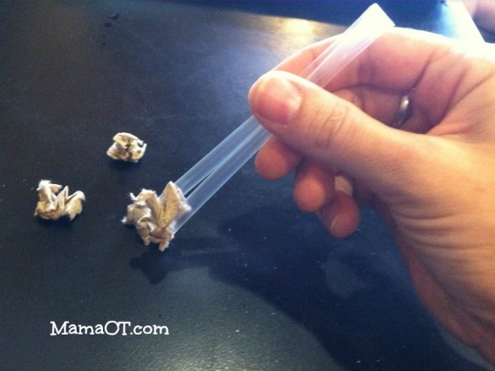 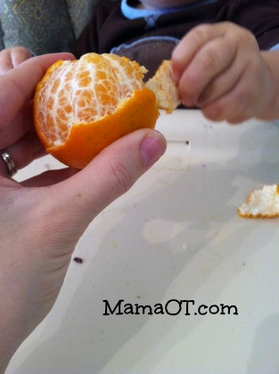

**14) Pull a scarf out of a baby wipes box -** Or you can use a tissue box.

**15) Pour water from one container to another -** Any water play is great for hand strength!

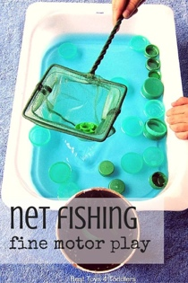**16) Fish bottle lids out of the water tray with a net.**

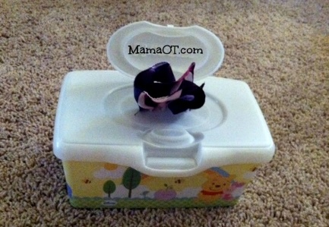 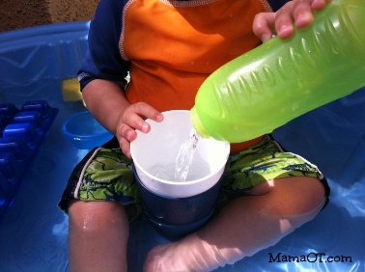

Find these and many more fine motor activities on www.mamaot.com!