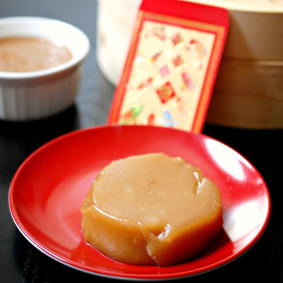Chinese steamed sticky rice cakes (nián gāo)

**Ingredients**

* 200 grams glutinous rice flour about 8/10 of a cup
* 150 grams light brown sugar packed (a little over 1/2 a cup)
* 100 ml hot water a little under 1/2 cup
* 100 ml room temperature water a little under 1/2 cup

**Instructions**

In a large bowl, whisk together the brown sugar and 100ml of hot water. Keep whisking until the sugar dissolves. Then mix in the 100ml room temperature water until fully incorporated.

Slowly add in the glutinous rice flour and mix until a smooth batter is formed.

Grease a large pan, bowl or individual ramekins (alternatively, you can line your container with buttered paper).

Pour the batter in your container and steam over high heat for about an hour. Check your nián gāo about 40 minutes in by inserting a toothpick near the centre of your pan. The mixture should no longer be watery and bits of the nián gāo may start sticking to the toothpick - this is good.

Once the nián gāo is done steaming, you can invert the cakes onto a flat plate to allow it to cool (or you can keep it in the container).

**Notes**

Store the nián gāo by keeping it in an airtight container or wrapping it tightly with cling wrap. It can stay in the refrigerator for about a week, but it can also be stored at room temperature for about 3 days.