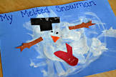**Melted Snowman Painting**

**You will need:**

White paint

Blue Card

Paintbrush

Coloured card – cut into shapes of arms, a hat, a nose and a scarf

Googly eyes

**How to make:**

1. Encourage your child to use their hands or a paint brush to cover their blue card in white paint.
2. Help your child to stick the cut out snowman shapes and googly eyes anywhere they would like on the white paint to create their melted snowman!