**MAGIC COLOURED BEANS SORTING ACTIVITY**

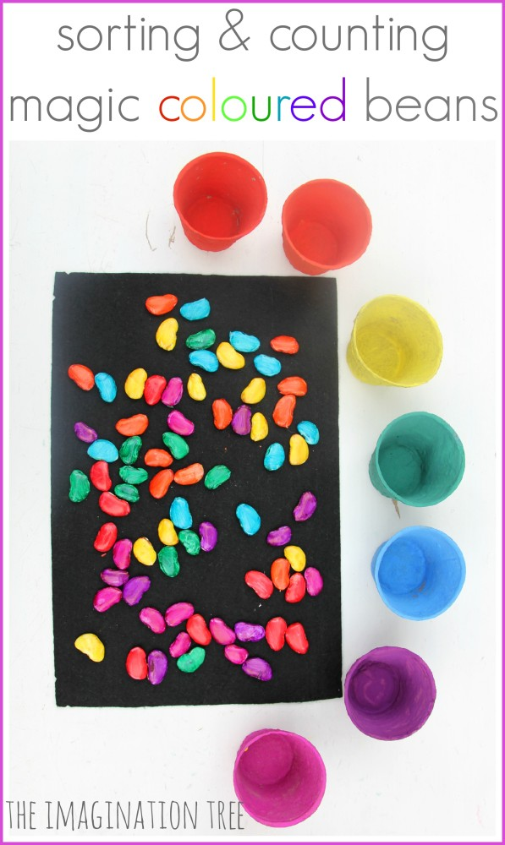

Make some magic coloured beans as a great DIY resource for [sorting](https://theimaginationtree.com/category/sorting-and-matching), counting, imaginative play and storytelling! These are so simple to make and are hugely appealing to play with.

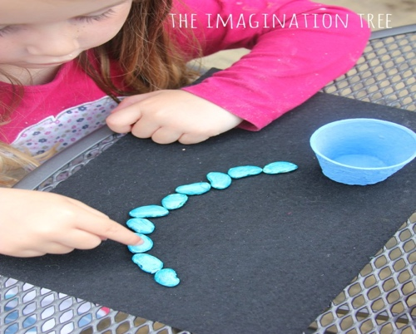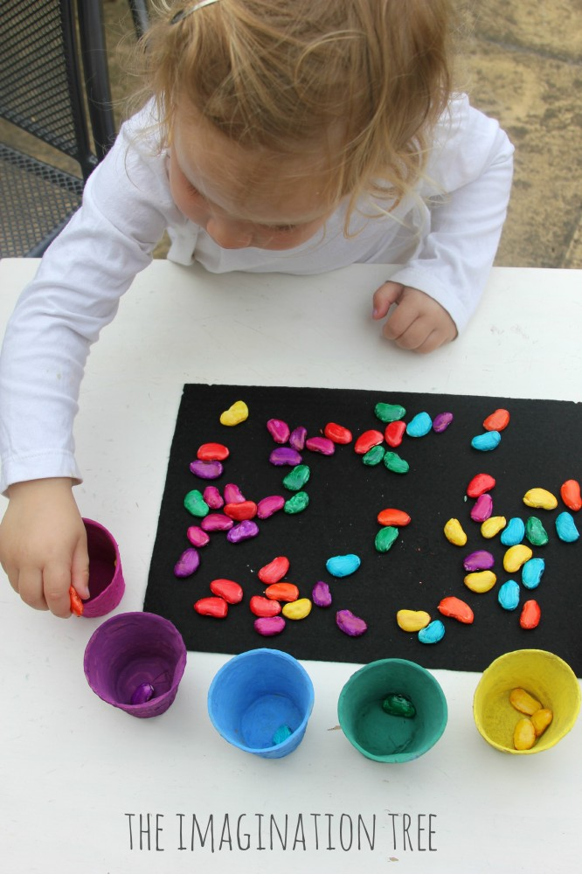

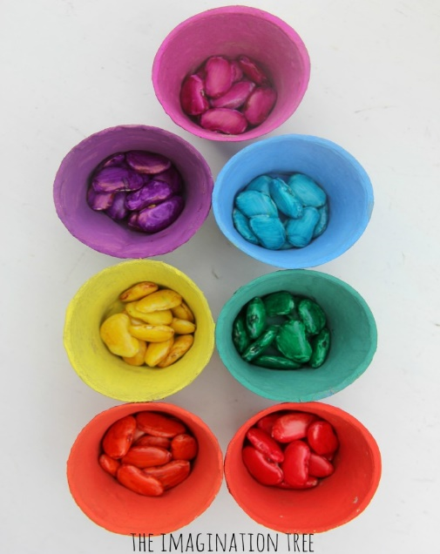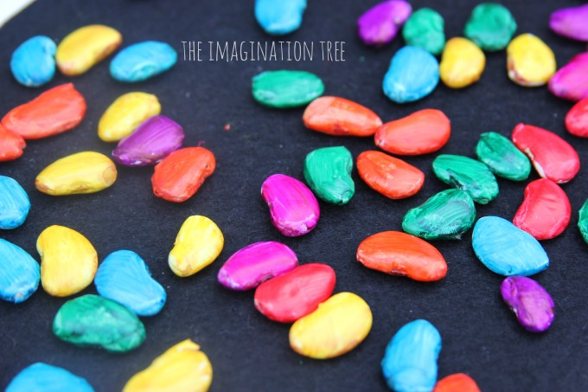Simply turn white butter beans into magically coloured rainbow beans using food colouring.

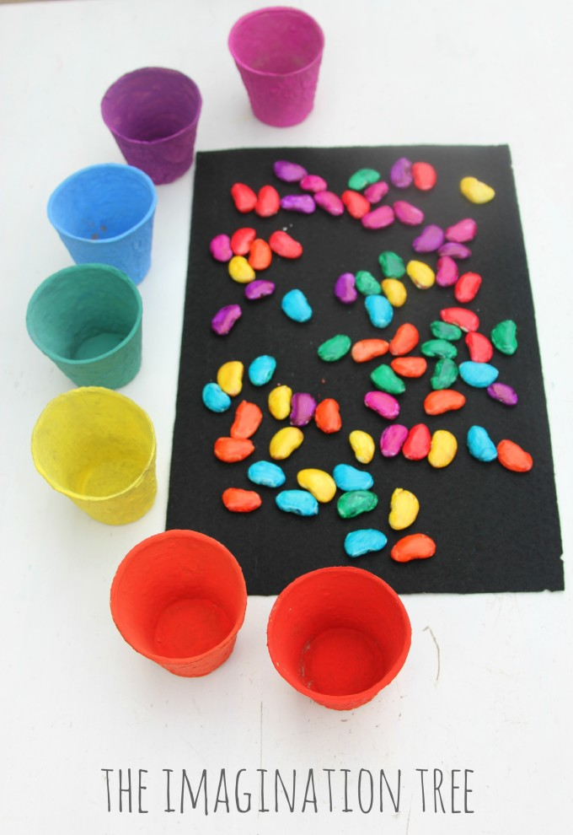You can colour 10 beans in each colour of the rainbow, then paint 10 little compostable potting pots/yoghurt pots to match, using paint and PVA glue mixed. When dry, mix them up and lay them out on a piece of black felt as a sharp contrasting background, with the pots next to them, and let the kids to play!