**COUNTING AND ADDITION WITH SHAPES**

Make an easy counting, sorting and addition game using shapes and homemade number cards for a playful, open-ended maths activity!

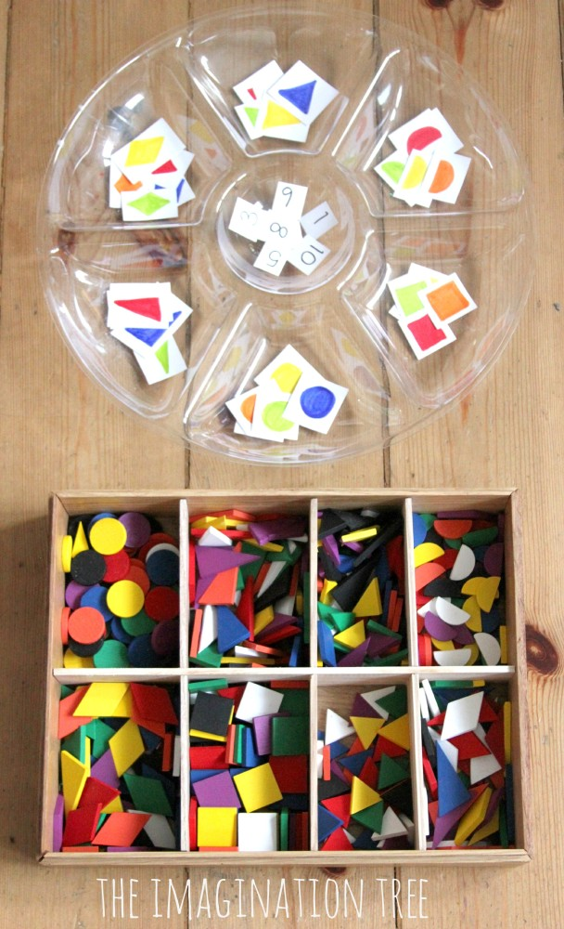

Select 6 different sets of the coloured 2D shapes and draw one of each colour onto a little piece of card, then placed them into the sections in a dip dish (what you use at parties to put dips in!). Then write the numerals 1-9 onto little pieces of card and placed those in the middle

Start off by simply choosing one number card and one shape card at random, then set about finding the correct number and colour of each shape to match.

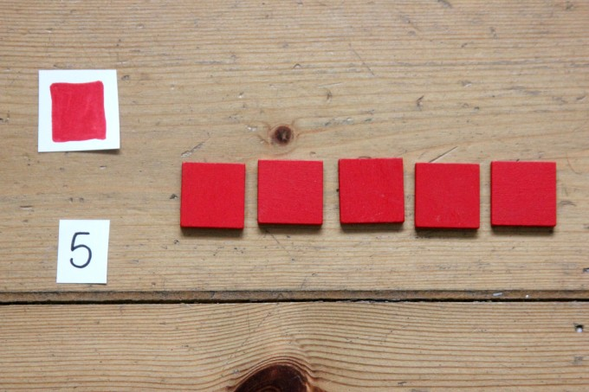

Children can count them out using 1:1 correspondence (i.e. moving one object each time so the number matches the item)

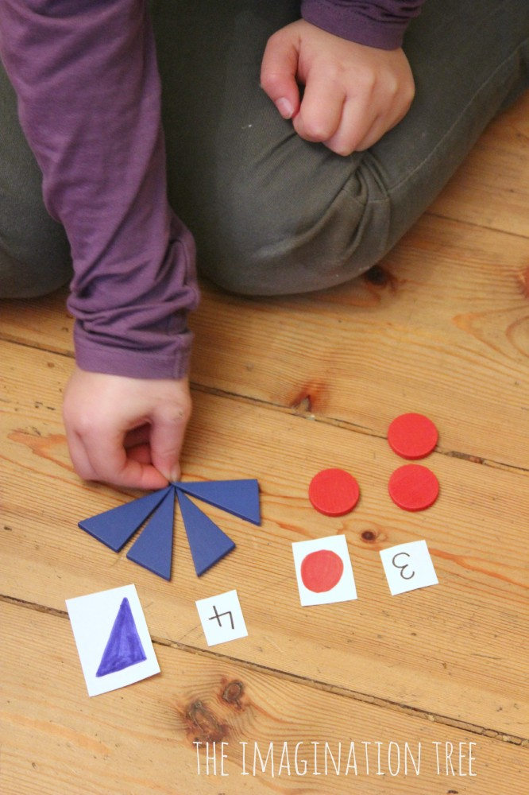

You could also move onto adding together small sets of objects and finding the total amount.

