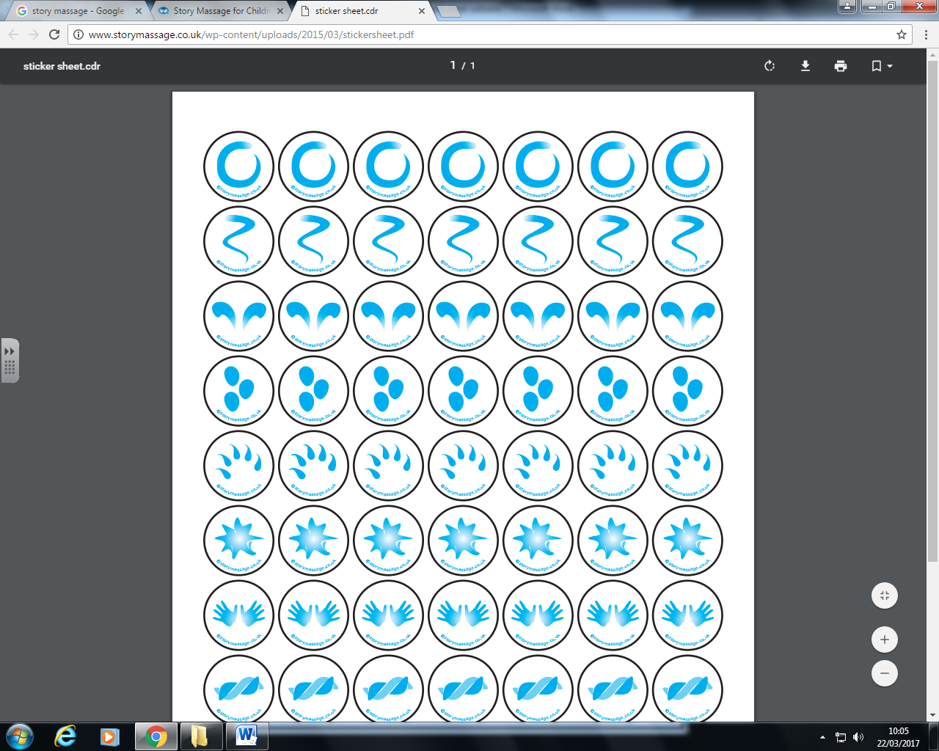



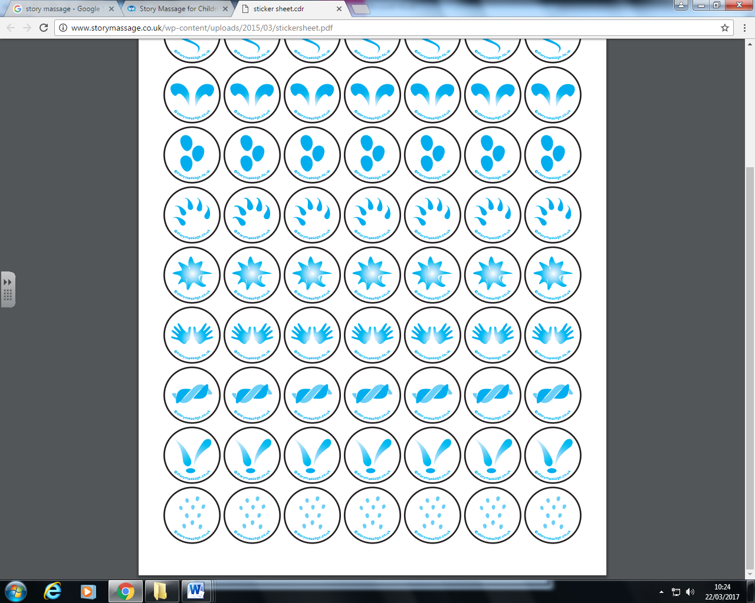









Ran away with the spoon.

And the dish

To see such fun

The little dog laughed

The cow jumped over the moon

The cat and the fiddle

Hey diddle diddle

**Hey diddle diddle**