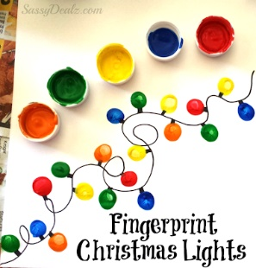**Christmas Finger Print Lights**

<https://www.craftymorning.com/fingerprint-christmas-light-craft-for/>

**You will need**

Paint tray

Different coloured paints

Card

Wool / ribbon / black pen or paint.

**How to make:**

1. Make the ‘string’ for the Christmas lights by either using a pen or paint to draw it on, or by using wool or ribbon.
2. Encourage your child to choose the coloured paints that they would like to use.
3. Help your child to dip their finger into the paints and to make fingerprints along the wool / black pen or paint.