Welsh Lady Craft

Here's an original craft for St David's Day! Raid your junk drawer to make this Welsh lady in traditional dress...

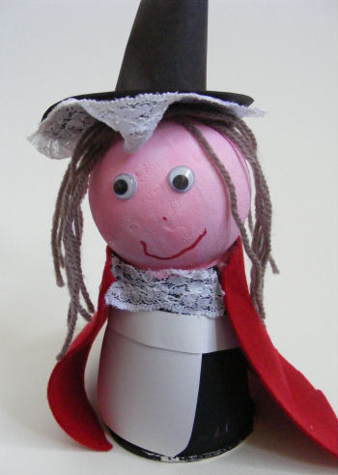**You will need:**

Polystyrene ball  
Paper cup  
Glue  
Black paint  
Pink paint  
Black paper  
White paper  
Red fabric  
White lace  
Wool for hair  
Wiggle eyes  
Red pen

**Instructions:**

Glue the ball to the bottom of the cup. Paint the ball pink and the cup black. Leave to dry.

Cut a small collar of lace and glue this to the top of the cup where it meets the ball.

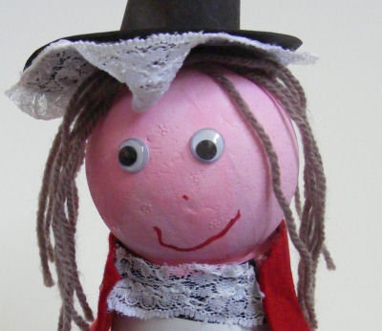Make an apron from a rectangle of white paper glued to the front of the cup and a strip of white paper glued around the middle of the cup at the top of the rectangle.

Make two arms from rectangles of white card, and glue these to the sides of the cup. Cut a cape from red fabric and glue around the top of the cup.

To make the hair cut lengths of wool and glue to the top of the ball so they hang down either side.

To make the hat, cut a circle of black paper and a strip about 8cm by 6cm. Roll the strip into a tube and glue to secure. Snip along the bottom of the tube and fold the trimmed edges in. Glue the tube to the centre of the circle. Glue a ring of lace around the edge of the other side of the circle. Now glue the hat to the top of the head.

Finish off by gluing on two wiggle eyes and drawing a mouth and nose.