***Fill the bucket with Love and Kindness***

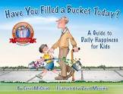As our topic is “A fresh start”, we have a beautiful story called “Have you filled a bucket today?”

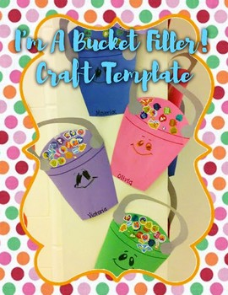Why don’t you try to fill your bucket with lots of love notes and kind messages?

Print out our printable message cards and fill your bucket every day!

*I love you because….*  *I love the way* ……

*You are amazing because…. You are wonderful*

*Because….*

*You made my day very special I love you very much*

*Because…. Because…*



*I am very proud of you You made me very proud….*

*because….*

*You are my hero because… You are my star…*

*You made me smile Because….*

