Paper Plate Snail

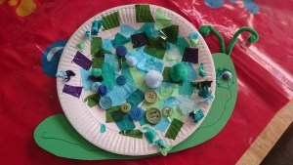

**To make the snail you will need:**

A paper plate, Green card, Tissue paper, Coloured Cellophane

Pom poms, Buttons, Wiggly eyes, Pipe cleaner, Glue

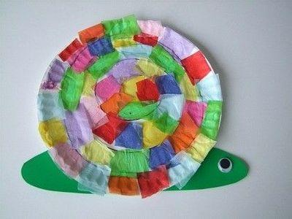 Felt pen, Sellotape

To start, rip up bits of tissue paper and the cellophane into small pieces.

Then stick the tissue papers, cellophane, pompoms and buttons onto a paper plate with glue. Let the children feel and explore each of the materials.

Cut the body shape from the card and stick a decorated paper plate onto the body.

Finally, glue the googly eye and sellotape pipe cleaners as antennae!