

**Daffodil pinwheel**

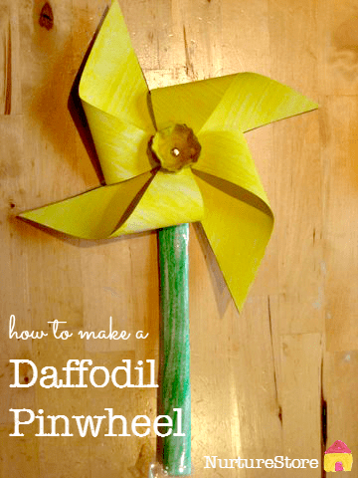You will need:

* yellow card (or white card and yellow paint)& green card
* egg box
* paper fastener / split pin
* yellow and/or orange paint
* a small paint brush
* stapler
* ruler
* pencil
* scissors

**How to make a daffodil pinwheel spinner**

Start by cutting a square from your yellow card.

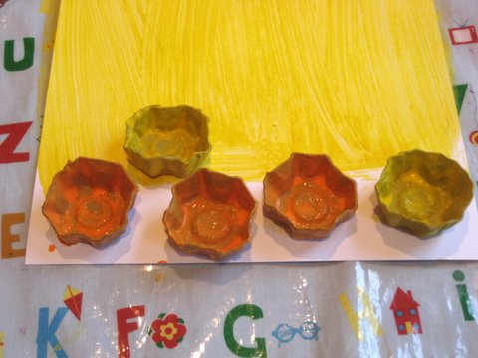Next, cut out the cup part of the egg box – this is going to be the trumpet part of your daffodil. Paint it either yellow or orange, depending on what colour you would like in the centre of your flower.

To create your daffodil flower, you need to fold in four of the edges, as shown below. Fasten them in place with a stapler.

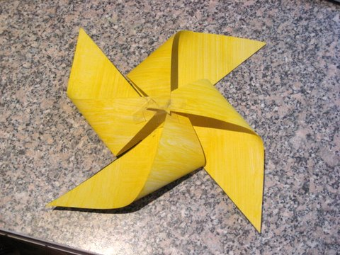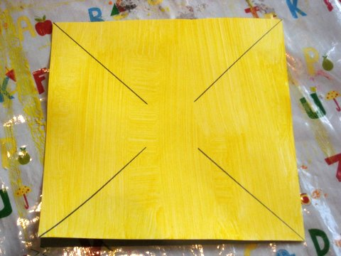

Make a stalk for the daffodil by rolling a piece of the green card into a tube.

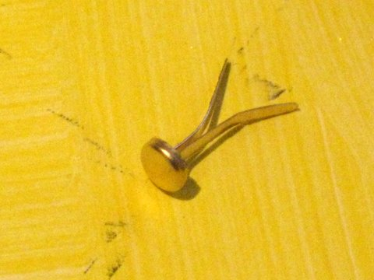Use a paper fastener / split pin to join the egg box trumpet, the daffodil and the stalk all together.  You can poke the paper fastener straight through the card but you might find it easier to make a hole with either a pencil or craft knife first. You want the hole to be loose enough for the daffodil to twirl around to give you the windmill effect.

And there you have it – a beautiful daffodil. You could make a few of them in different shades to make a lovely spring bouquet.

