Our Welsh National bird

Red Kite

What do they look like?

Red kites are 60 to 70 cm (24 to 28 in) long. It is an elegant bird, soaring on long wings held at a dihedral, and long forked tail, twisting as it changes direction. The body, upper tail and wing coverts are rufous. The white primary flight feathers contrast with the black wing tips and dark secondaries. Apart from the weight difference, the sexes are similar, but juveniles have a buff breast and belly.

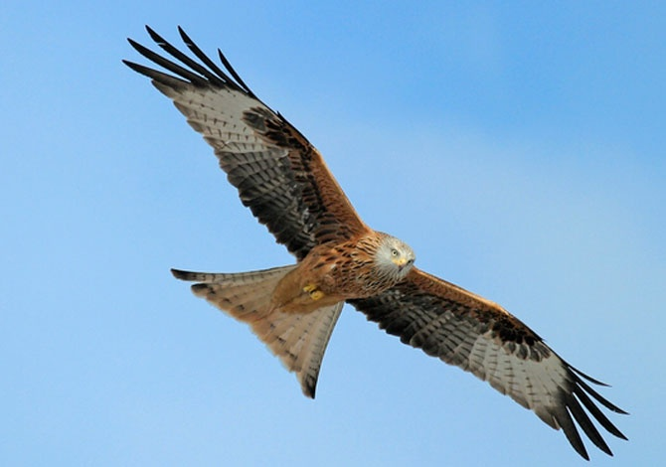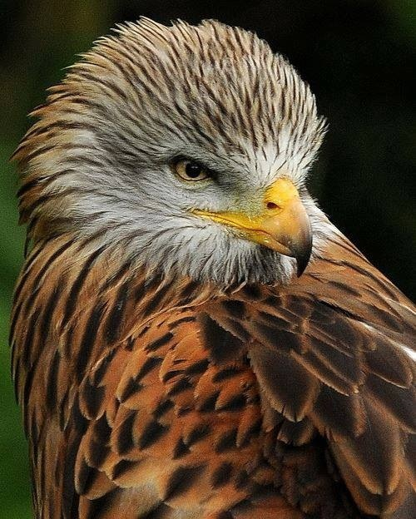

How they fly?

<https://www.youtube.com/watch?v=10Drb9zKMMM>

what is Red kite’s sound like?

<https://www.youtube.com/watch?v=yMaDJur6y54>