**The Very Hungry Caterpillar Paperchain**

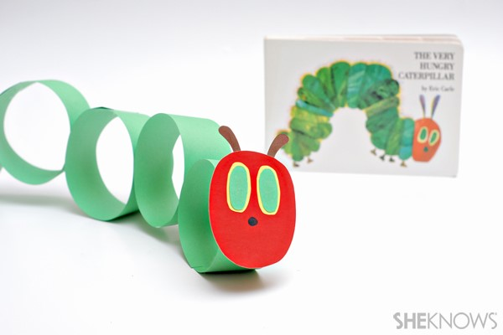

**What you’ll need:**

* green paper
* red paper
* yellow paper
* brown paper
* scissors
* glue
* markers

**How to make it:**

1. Cut six strips from the green paper that are 1 inch wide and 6 inches long.
2. Glue the end of the strips together to form a ring.
3. Glue the green rings together to make a chain.
4. Cut an oval out of the red paper, glue it to the end of the chain to make the caterpillar’s face.
5. Cut two small ovals out of yellow paper, and two slightly smaller ovals out of green paper. Glue the green ovals on top of the yellow ovals to make the eyes, then glue the eyes to the caterpillar’s face.
6. Cut two skinny strips from the brown paper. Glue them to the top of the caterpillar’s face to make the antennae.
7. Draw a nose on the caterpillar’s face with a marker.