Handprint Dragon

Five handprints combined with some paper shapes (cut out using our template) produce this fantastic, fierce dragon - a fantastic craft for Chinese New Year or a China theme, a fairy tale theme, or even St George's Day or St David's Day.

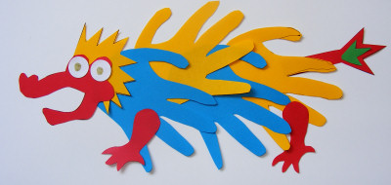

**You will need:**

Coloured paper  
Handprint dragon template (below)  
Glue  
Small white circle stickers  
Black pen  
Large sheet of paper

Print our template out onto card. Cut out and use it to draw and cut out a head, mane, tail and two legs from coloured paper.

Draw around your hand 5 times on coloured paper, and cut out. Glue the handprints in a line across your large sheet of paper to form your dragon’s body, referring to the photo above for positioning. Stick on the mane and the head. Add the tail and two legs. Stick on the two stickers as eyes and with the black pen draw on the pupils, nostrils and teeth.

**Variation:**

1. Instead of cutting around your child's hand onto coloured paper, make handprints with bright coloured poster paint on white paper. When dry, cut out as before.

2. Make this dragon as a classroom project with as many hands as you like - just give him an extralong body!