**Mother’s Day Fingerprint Flower Bouquet**

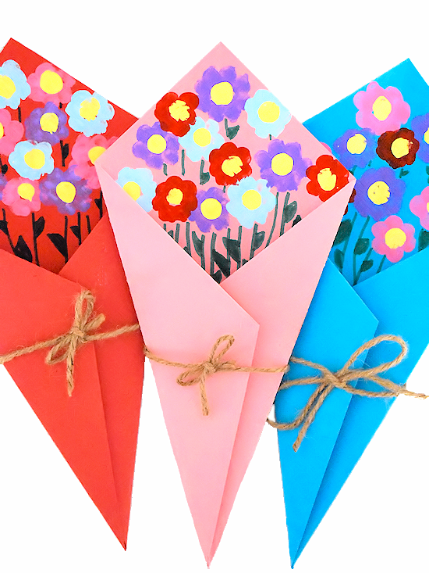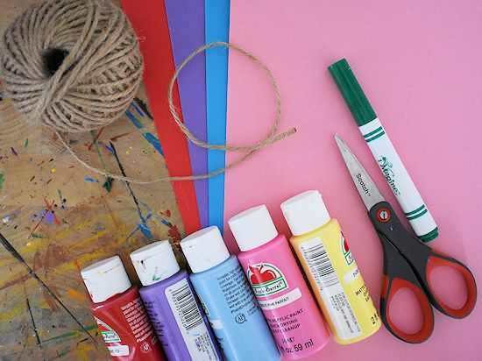Mother’s Day is the perfect occasion for handmade, hand-crafted gifts like this **Mother’s Day Fingerprint Flower Bouquet**. It’s sweet as can be, with bright spring flowers made from little ones’ fingerprints.

Supplies needed for fingerprint flower bouquet

* Paints (red, pink, purple, blue and yellow for centre.
* String
* Green markers
* Glue
* Scissors
* Cards (different colours)

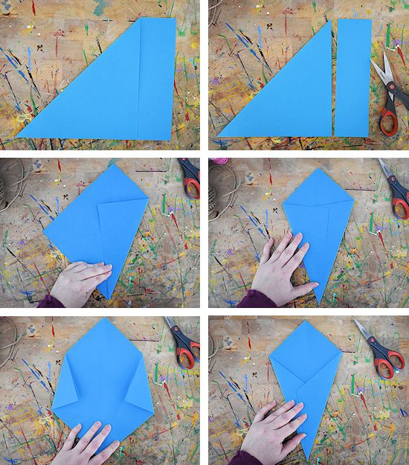Fold the overlapped points back. Then fold into place to make sure it’s positioned correctly.

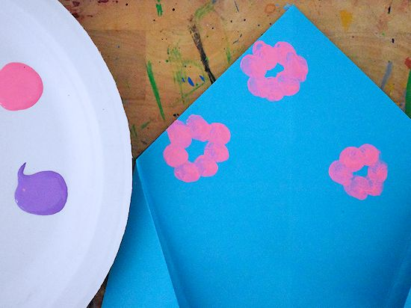

Unfold the front flaps of the paper and begin making flowers. Simply dip a fingertip into paint and dab the paper in a circle shape. Make some larger, some smaller. Let the flowers dry.

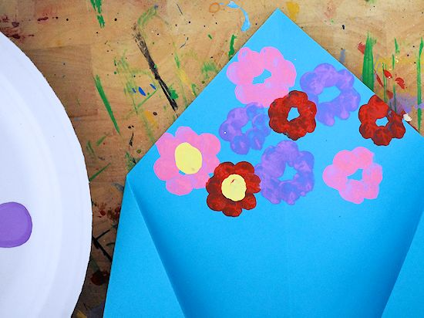Then dip a clean fingertip into yellow paint and dab in the centre of the flowers.

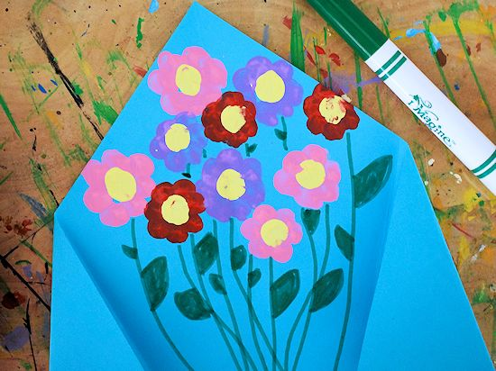

Use the green marker to draw stems and leaves down from the flowers.

Finish the flower bouquet by cutting a piece of string. Apply a glue dot to stick to the back of the paper and keep in place. You could also use clear tape instead.

