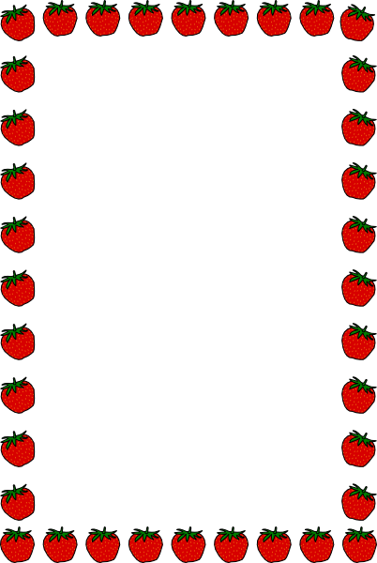

**Fruit salad making & counting**

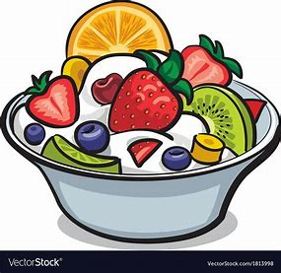**Ingredients**

**• 5 pieces of Apple**

**• 4 Strawberries**

**• 4 Blueberries**

**• 5 slices of Banana**

**• 1 table spoon of honey**

**• 2 table spoons of plain yogurt**

**Method:**

**Cut each piece of fruit with the child, count together while putting them into a bowl. (They can have smell and taste too as you go along!) Add honey and yogurt and mix them together. (or mash them to be the right texture for the child if needed). Now enjoy!**