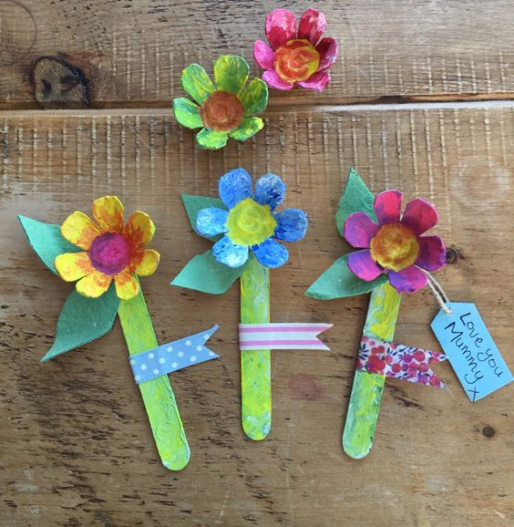**Egg box flowers**

**What you need:**

Egg box Lollypop sticks

Card/paper Colour paints

Glue Paint brushes

Small Buttons

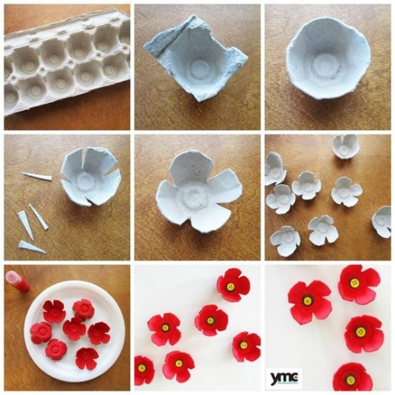There are 2 different styles of egg box flowers.

* First one is an individual flower.

1, Cut out each egg case from the box.

2, Trim the edges to make a round shape.

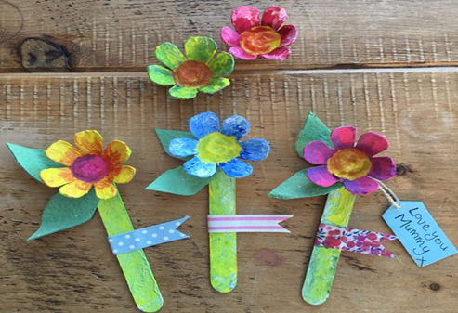 3, Cut 4 slits to make petals.

4, Paint the flowers and lollypops.

5, Cut the card paper into leaf shapes and glue them all

together and you are done!

* Second one is an egg box flower pot

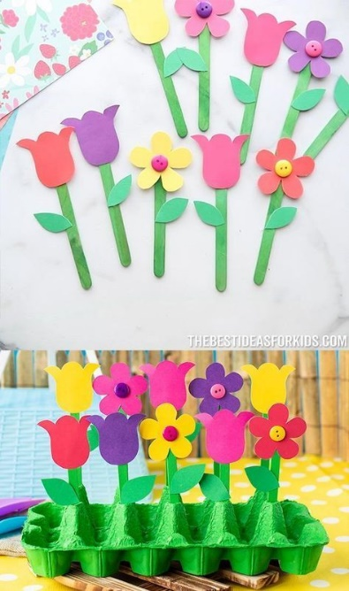1, Cut the coloured card (or you can paint white paper) into flower shapes. (About 9 flowers)

2, Paint the lollypop sticks and an egg box in green.

3, Glue the flower, leaves and stem together.

4, Stick and stand them in an egg box to look like plant pots!

