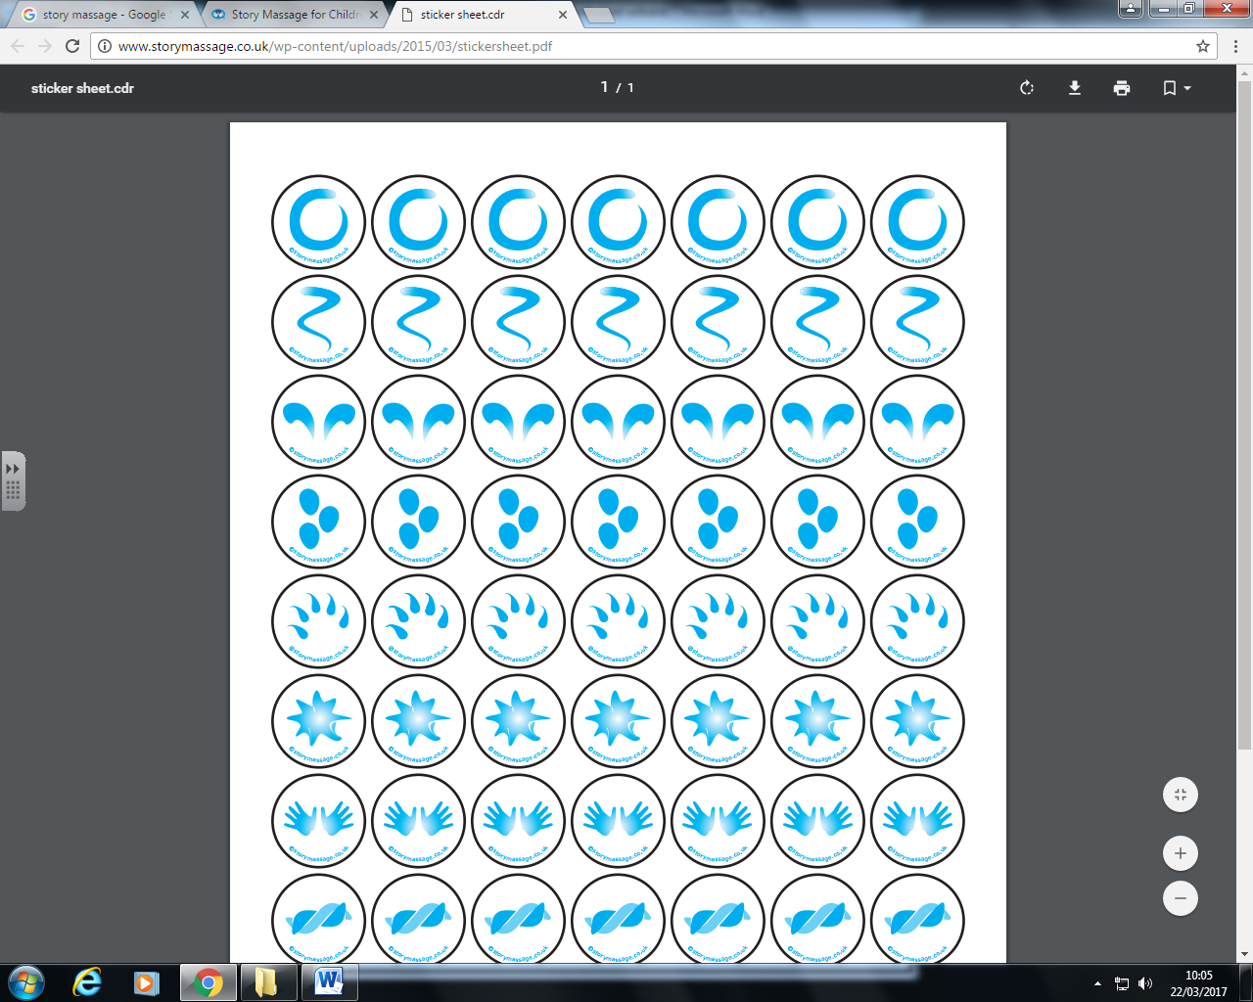

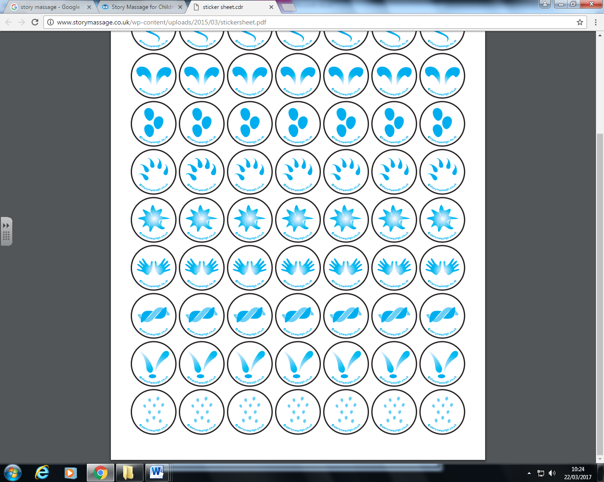



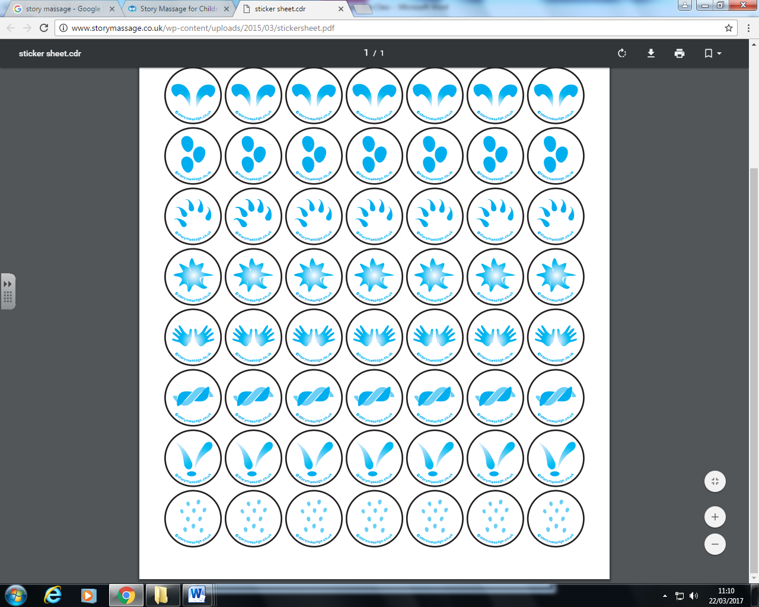

I’m wet through

And so are you!

Pitter patter rain drops,

Pitter patter rain drops

Hark don’t you,

Hark don’t you

I hear thunder,

I hear thunder

**I hear thunder**