Owl Babies Sensory Story
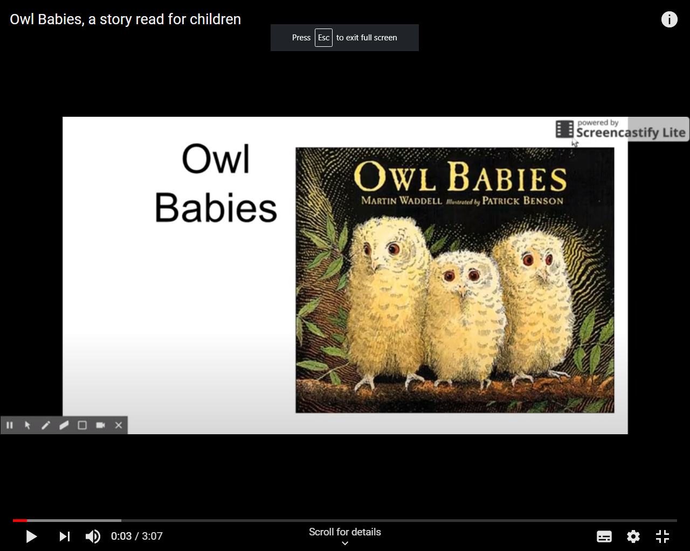

Buy the book:
https://www.amazon.co.uk/Owl-Babies-Martin-Waddell/dp/0744531675
Watch the story online:
https://www.youtube.com/watch?v=GyiBDPJCDFY

Introduce your child to the story by letting them explore the book. Use a soft cuddly owl toy as an Object of Reference. Where possible, sign that it is ‘time for a story’.
Pg. 1
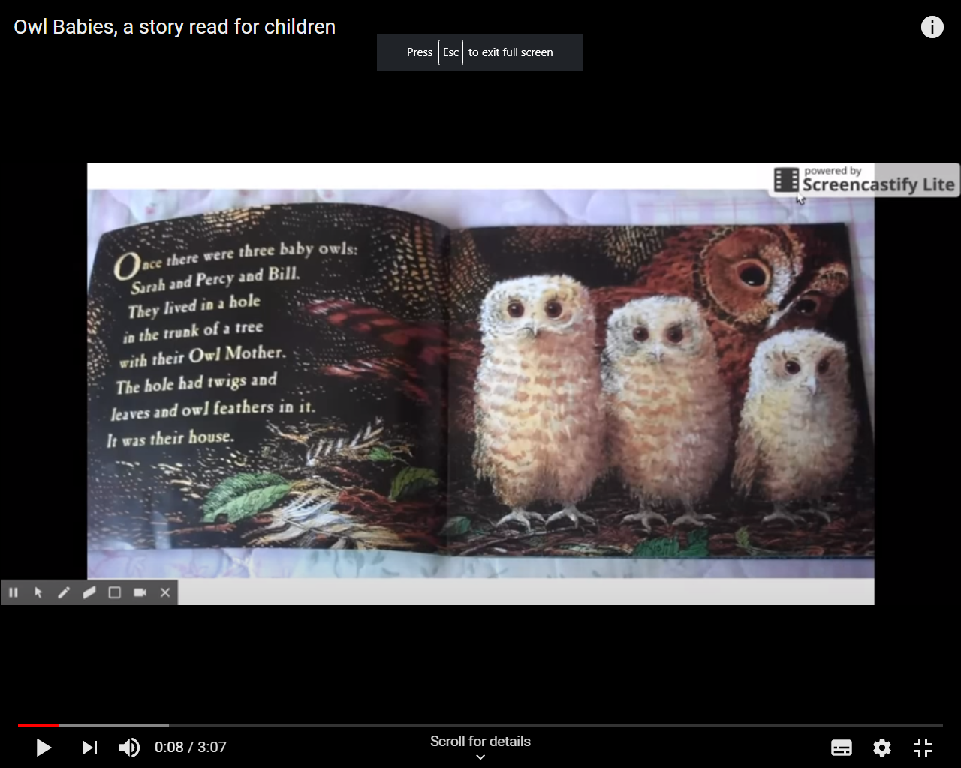
Introduce 4 owl toys, some feathers and sticks. Let your child explore the toys and materials.
Pg. 2
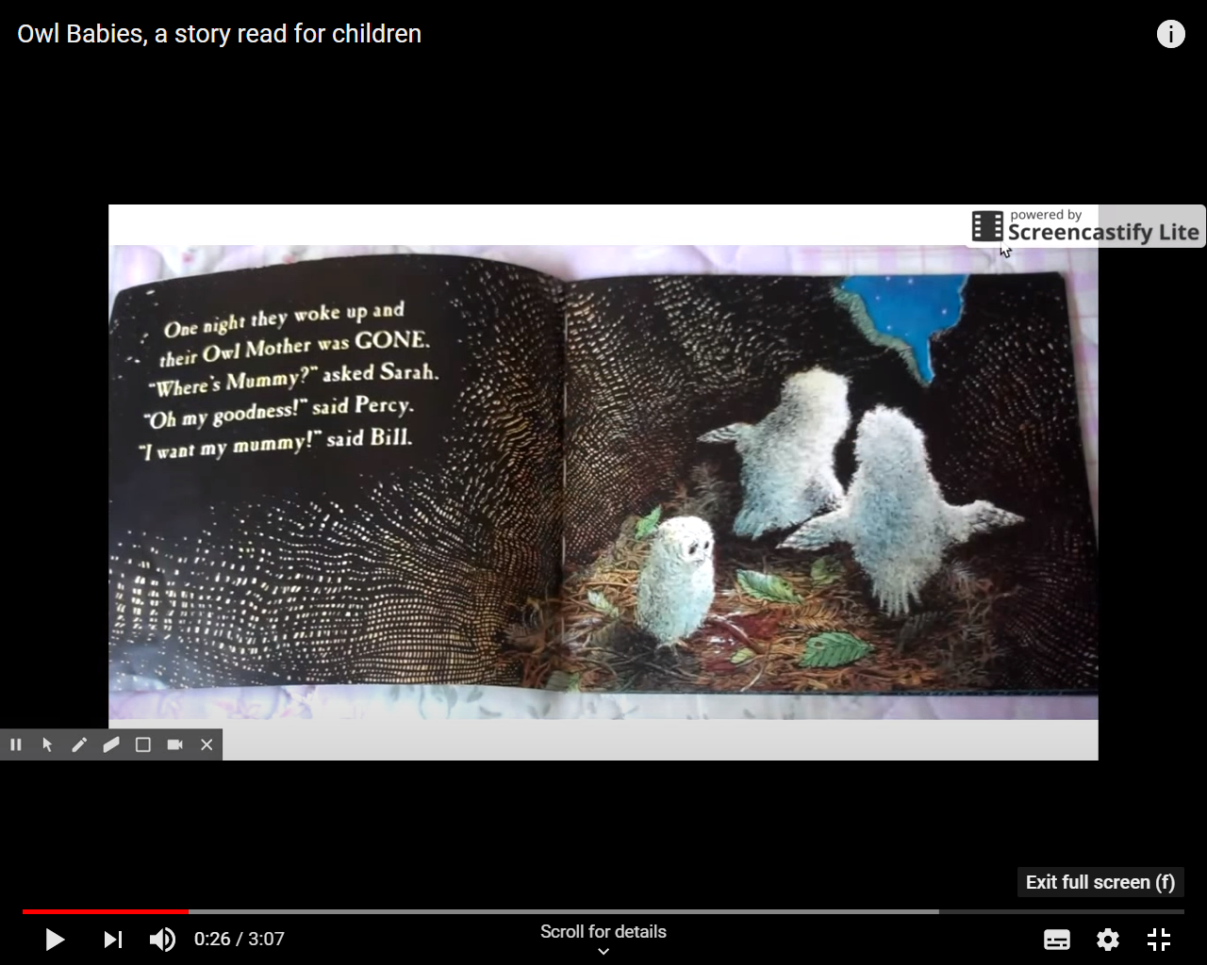
Show 4 of the owl toys, and then remove one of them as the mother has left the nest. Count together. Express how worried and curious the owl babies are.
Pg. 3
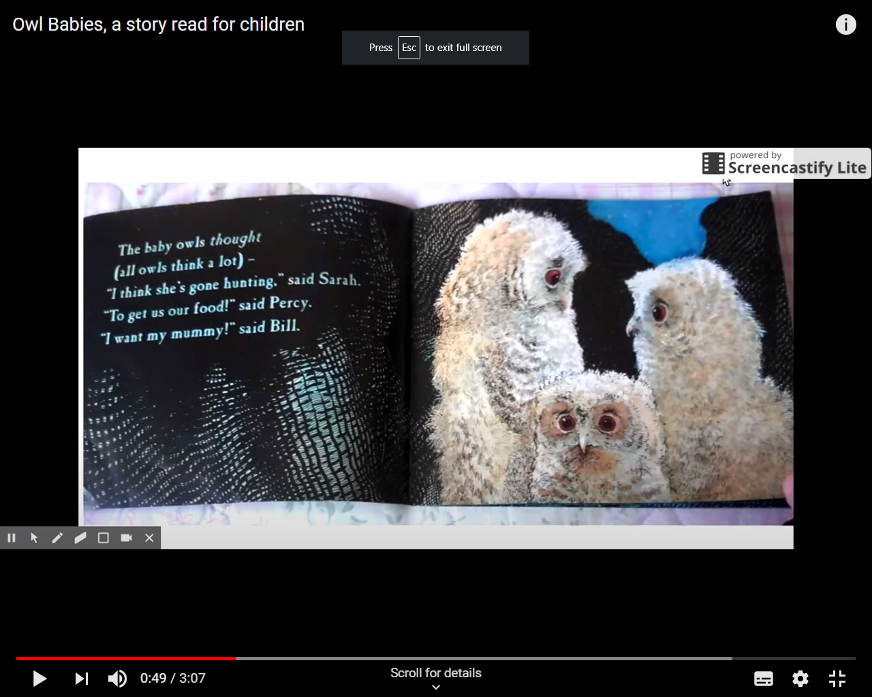
Use jelly worms or plastic bug toys when it is mentioned their mother has gone to get food. Let child explore the jelly worm texture.

Pg. 4
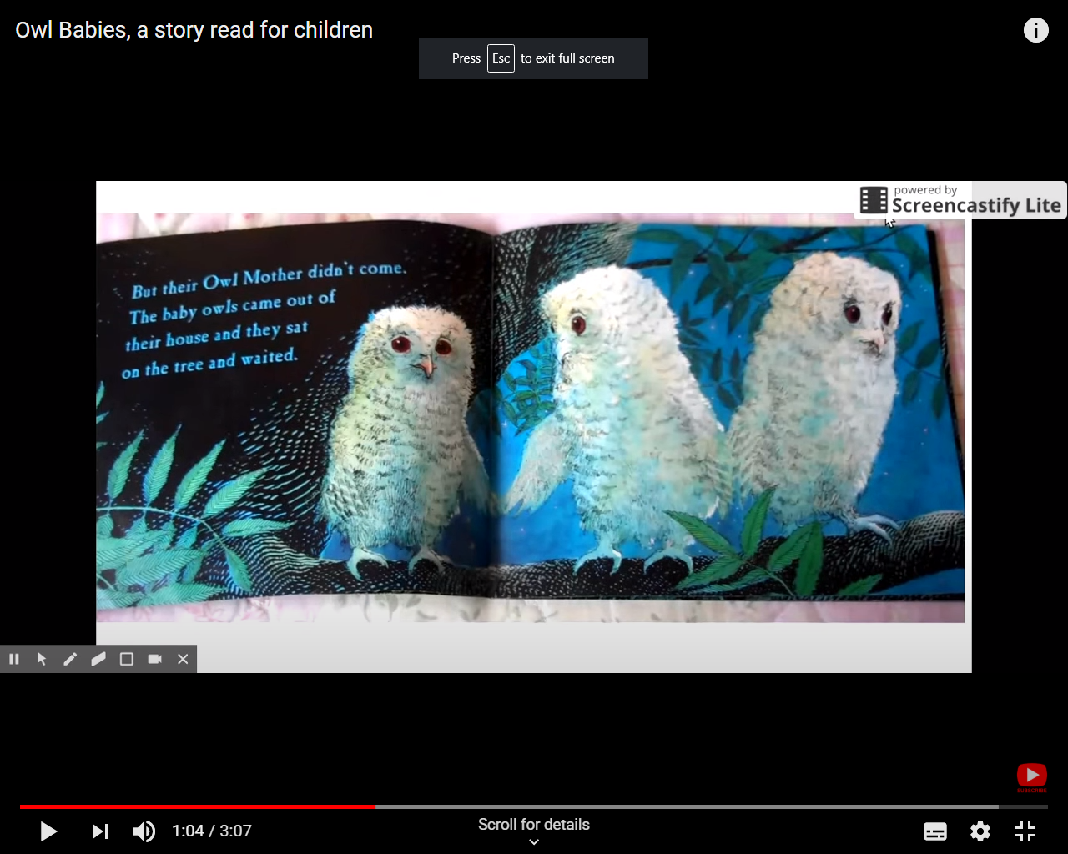
Introduce twigs and leaves to let child experience the texture of the owl’s habitat.

Pg. 5
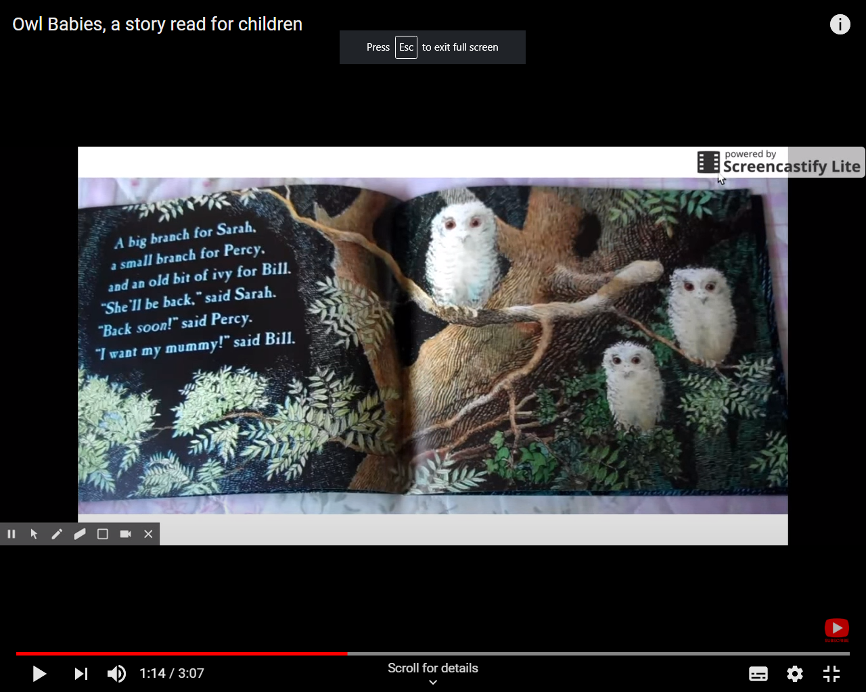
Use a big stick and small stick, encourage the children to recognise the difference between big and small. Show the children the owls sat on their branches and let them feel some vine/leaves.

Pg. 6
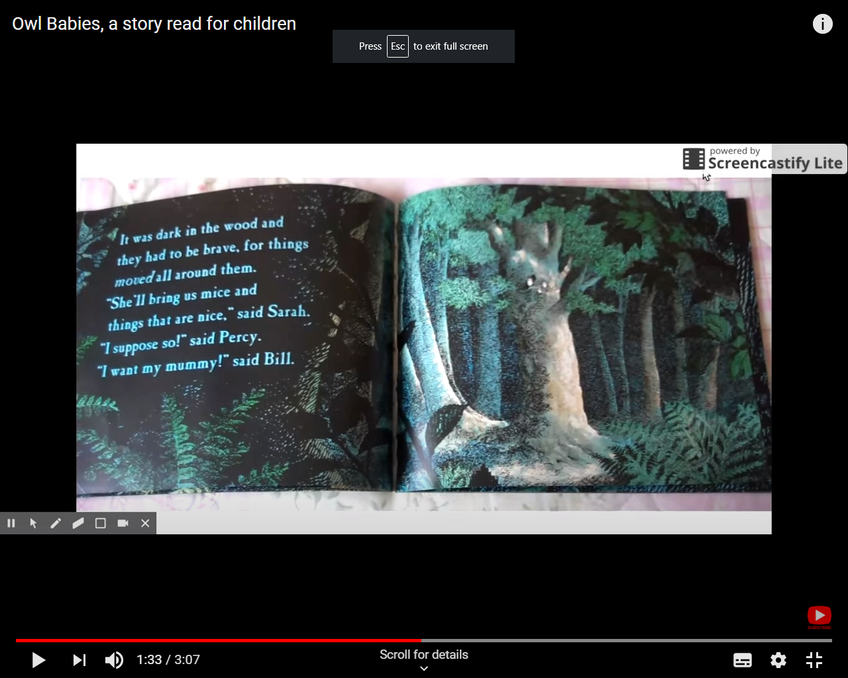
Use a blanket to imagine it being dark in the woods, drape over child and use a torch to encourage children to track light where possible using their eyes. Play some forest/nature sounds in the background.
Example: https://www.youtube.com/watch?v=OdIJ2x3nxzQ
Pg. 7
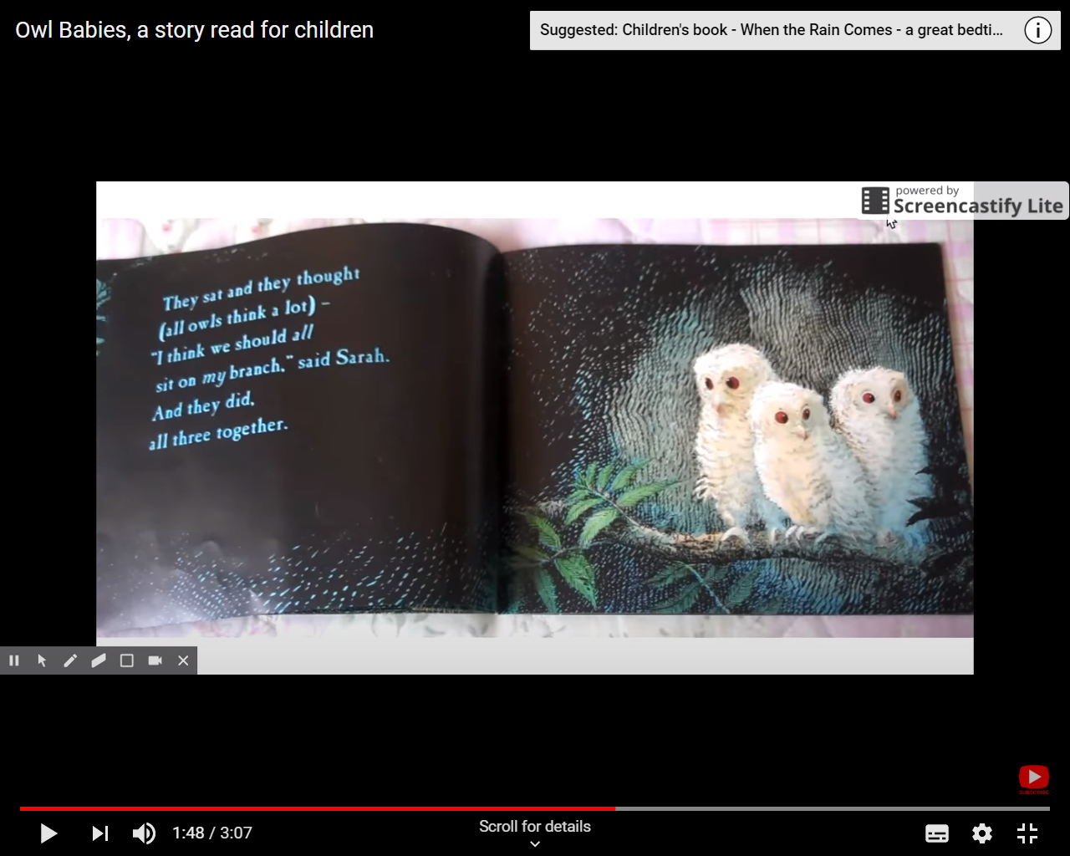
Allow the child to hold the owl close and hug it against their skin to feel the texture. If appropriate, also hug the child to see what it would feel like to sit close together.
Pg. 8
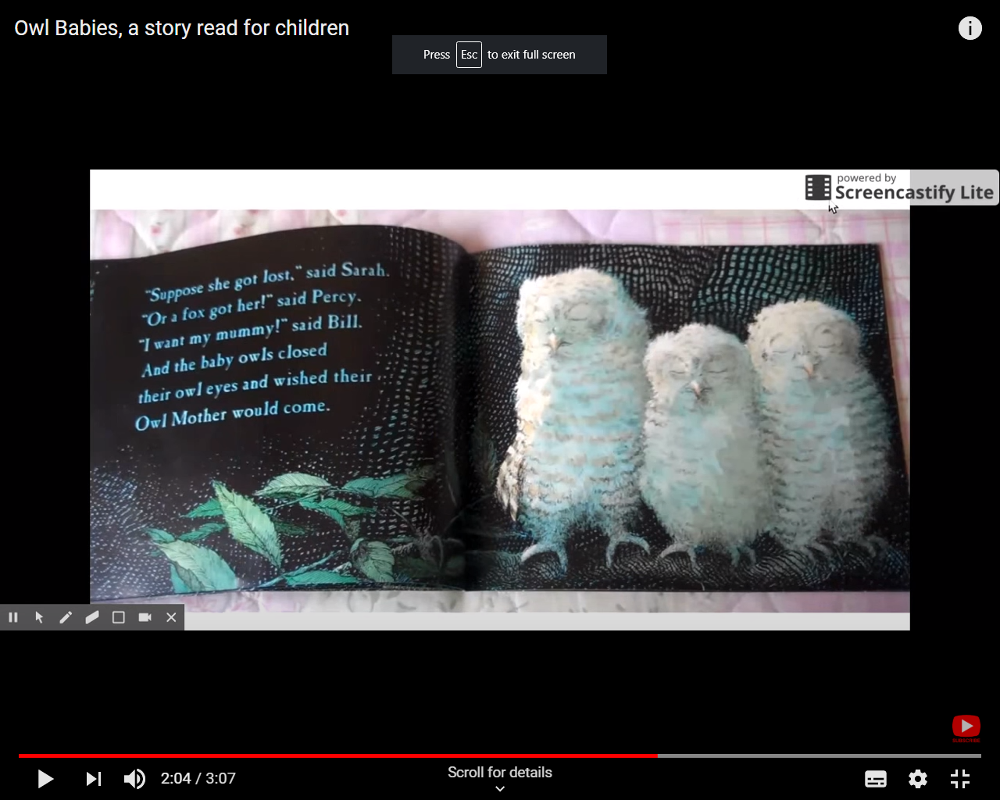
Encourage the children to close their eyes and ‘wish’ really hard. What do they wish for? If they cannot close their eyes, put sunglasses on to see what the world looks like when it is darker, like what the owls might see.
Pg. 9
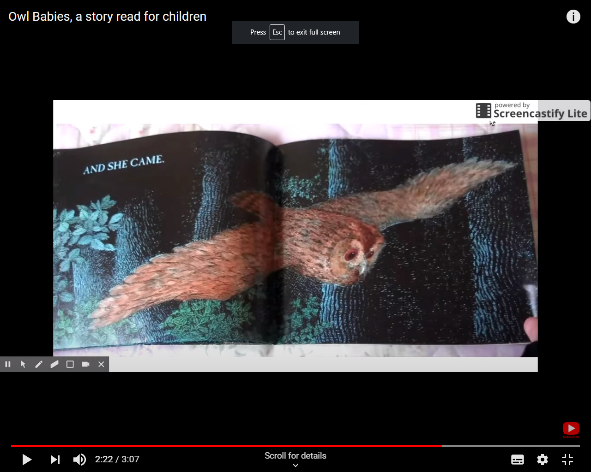
Use a large fan/make a fan out of card and flap over the children to feel the breeze as if the owl mother was flying overhead.
Pg. 10
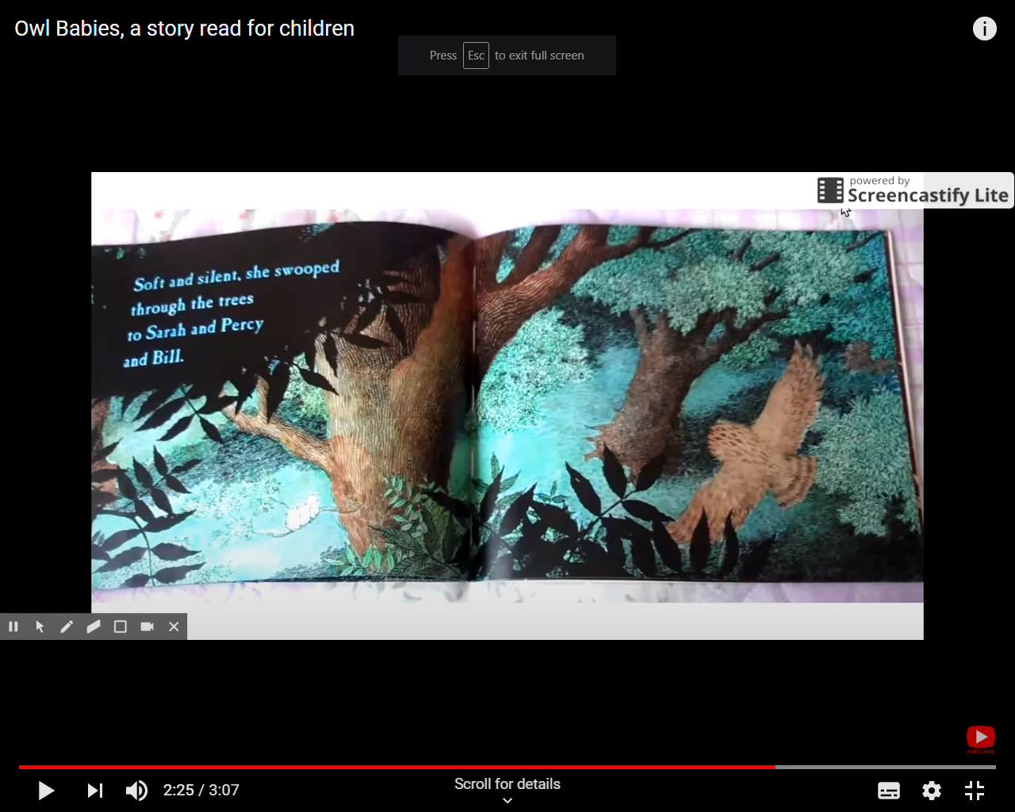
Use crepe paper streamers and drape over children to imagine mother flying through the trees. Optional – Use a fan to imitate the mother’s wings. Reunite the mother owl soft toy with the owl babies, count how many owls there are now and express how happy and pleased they are!

Pg. 11
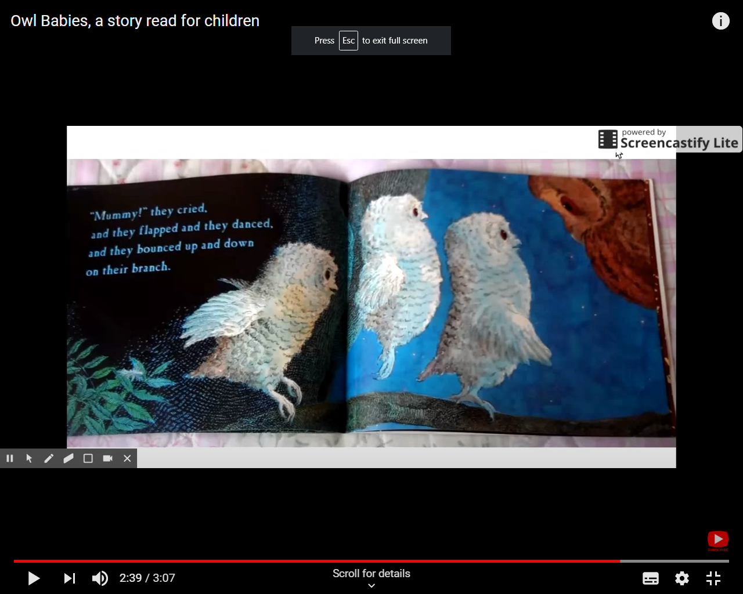
Use gentle massage tapping and bouncing on the children’s legs to pretend being the owl babies flapping and bouncing on the branch. Express how excited the owl babies are due to their mother’s return.

Pg. 12
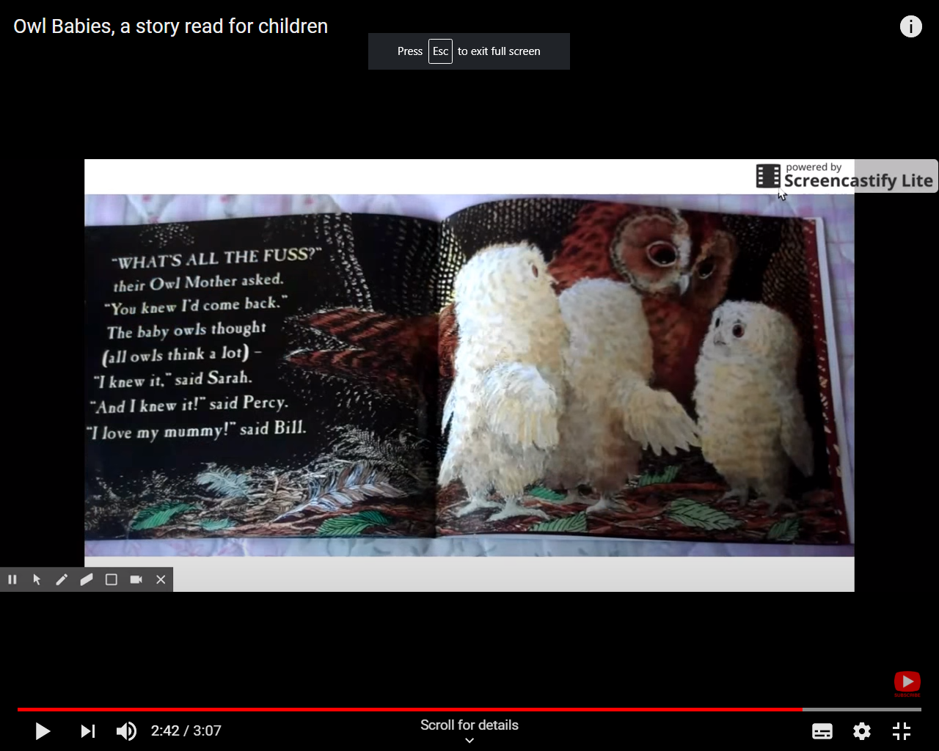
Finally, tell your child that you love them and given them a big hug.
Thank your child for listening to the story and sign that the story has finished if possible.
Allow your child to explore any of the materials that were used throughout the story at their own pace.

