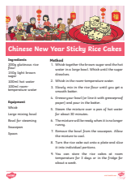

**Ingredients Equipment**

200g glutinous rice flour Whisk

150g light brown sugar Large mixing bowl 100ml hot water Spoon , Saucepan

100ml room temperature Bowls for steaming

warm water

**Method**

1. Whisk together the brown sugar and the hot

water in a large bowl. Whisk until the sugar

dissolves.

2. Whisk in the room-temperature water.

3. Slowly mix in the rice flour until you get a

smooth batter.

4. Grease your bowl (or line it with greaseproof

paper) and pour in the batter.

5. Steam the mixture over a pan of hot water

for about 30 minutes.

6. The mixture will be ready when it is no longer

runny.

7. Remove the bowl from the saucepan. Allow

the mixture to cool.

8. Turn the rice cake out onto a plate and slice

it into individual portions.

9. You can store the rice cakes at room

temperature for 3 days or in the fridge for

about a week.