 **Duck Handprint craft**

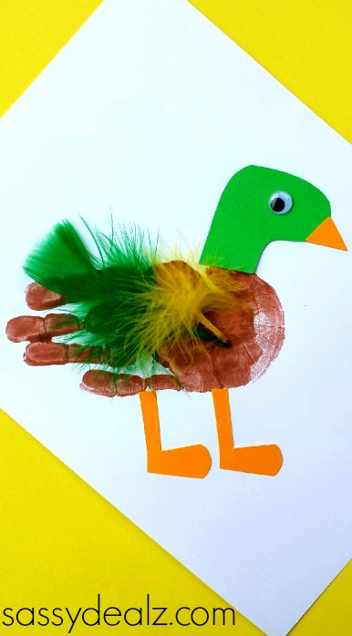**What you need:**

* brown paint
* a paintbrush
* green/yellow feathers
* glue
* scissors
* googly eyes
* green/yellow card paper

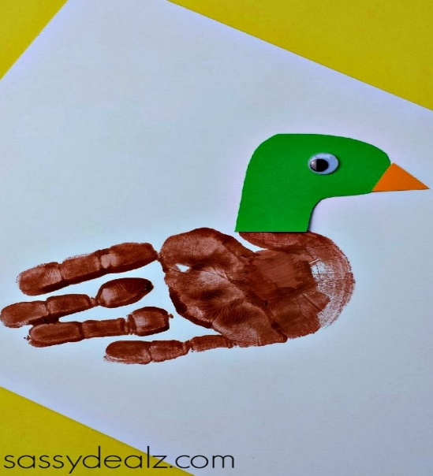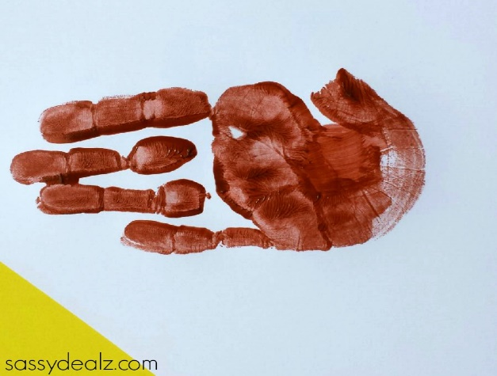**Method :** Start by painting your child’s hand with brown washable paint and pressing it onto a white sheet of paper.

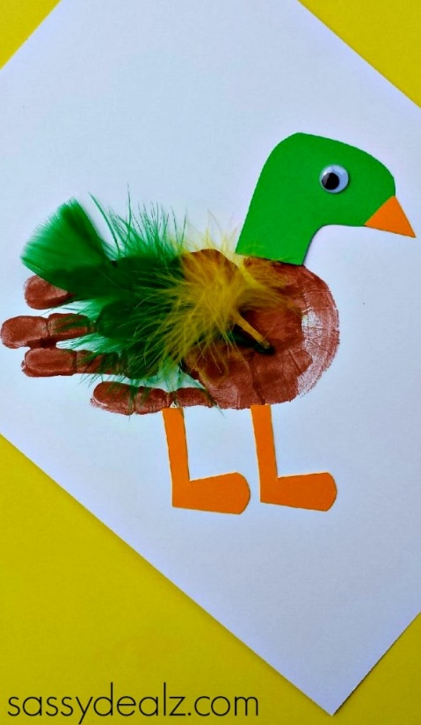Cut out a green duck head and beak. Glue them together, add a googly eye and stick to the base of the handprint.

Add some duck legs to finish off this cute art project!