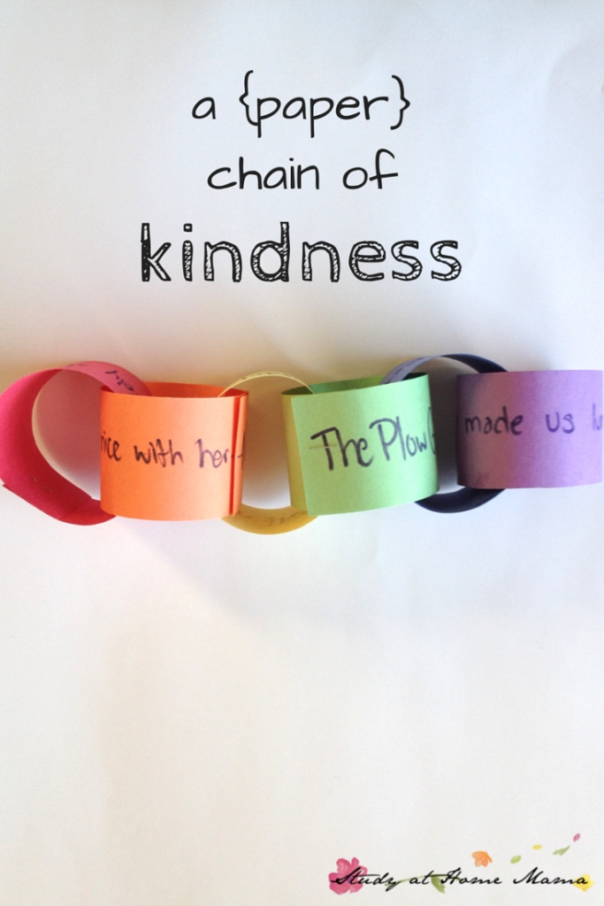**You need**

Different coloured papers

Scissors and glue

**Instruction**

Cut each different coloured paper into long strips.

Think about and write down acts of kindness, words or even emoji onto the strips!

Make a ring with strips and join them together one by one with glue to make a kindness paper chain to decorate your house or pass on to someone special!