**Spring themed sensory tray**

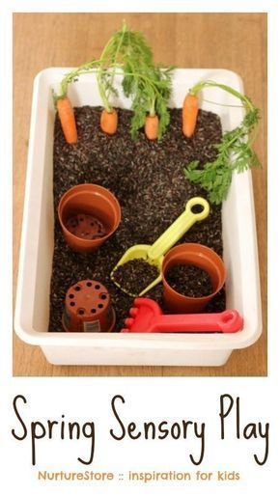

**You will need**

Dried rice - mix with brown paint and leave to dry

Vegetables

Spades

Plant pots

Bowl or tray