**Paper Plate Parrot Craft**

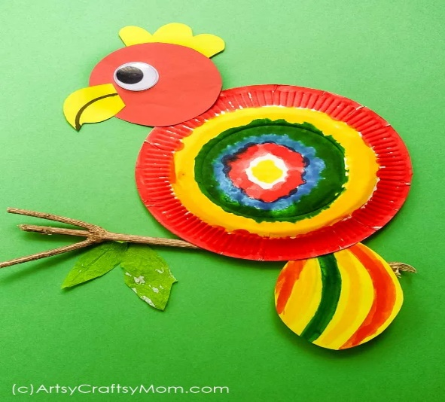

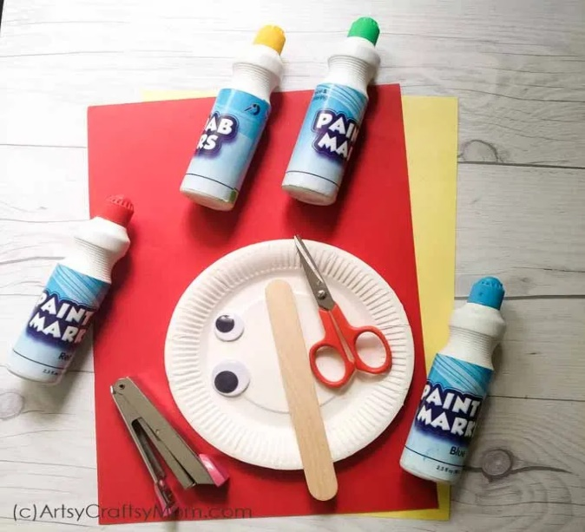**List of materials to make the Paper Plate Parrot Craft**

* One small circular paper plate– Either coloured or white
* Watercolours or Dot-to-Dot markers in various shades
* Glue
* yellow, red & white card paper
* Lolly stick
* Brown foam
* Staplers
* Black marker

**Instructions to make the Paper Plate Parrot Craft**

Cut a circle (4-inch wide) from the red card paper for the head and a 1-inch circle in white paper for the eye.

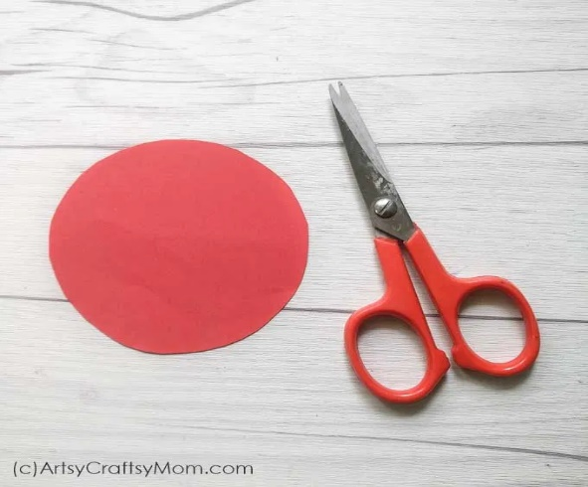

Use the yellow paper for the comb & beak. Outline it using a black marker.

Cut another piece of red or yellow construction paper for the tail feathers and colour it using water colours & dot-to-dot markers.

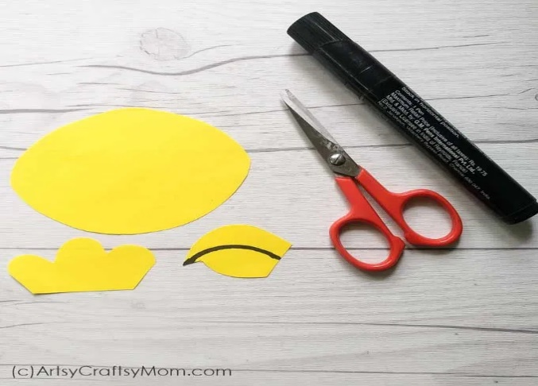

Colour the paper plate in various bright colours. This will form the body of the parrot. Colour the centre in a different colour and the sides of the paper plate in a different colour. Then use the dot-to-dot markers to add dots.

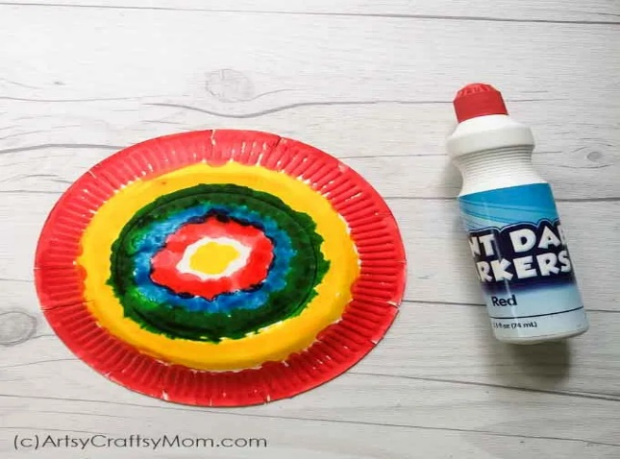

Let’s get the parrot’s face ready now: Stick the beak & comb on the red circle using glue. Stick the white circle for the eye. Using a black marker, outline the beak and add a black circle for the eye.

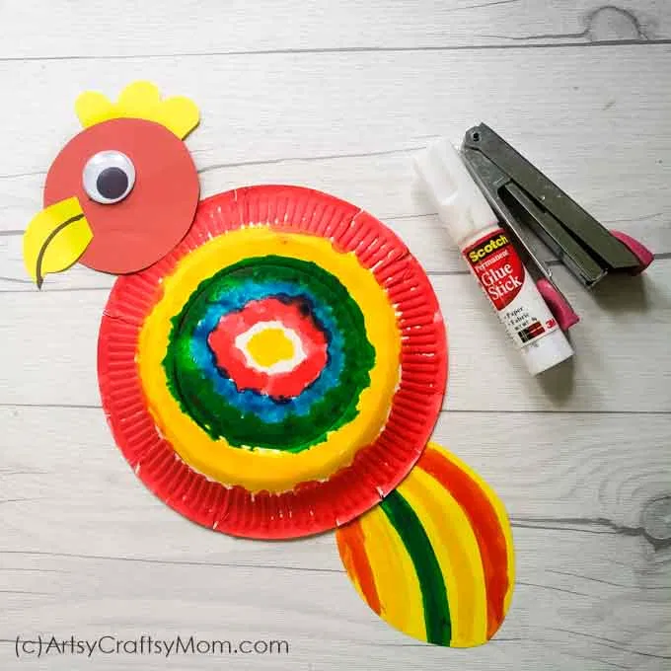

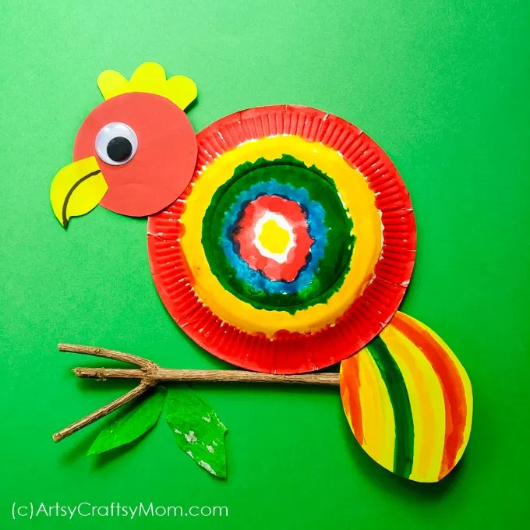Use a stapler and secure the head & the tail to the paper plate. Cut the brown foam into a claw and paste at the bottom of the paper plate. Glue a lolly stick at the bottom to make it into a puppet!