 **Sponge painting owl**

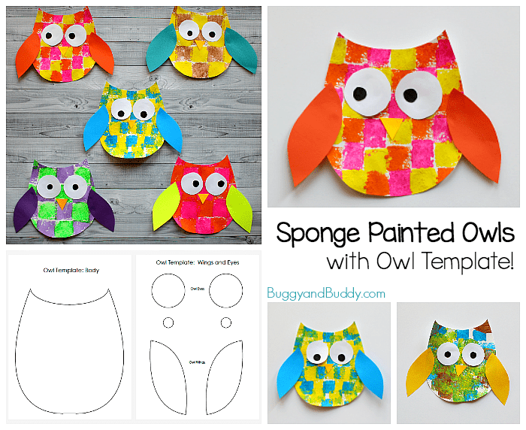 **What you need:**

* Dish washing sponge
* Scissor
* Colour paints
* PVA glue
* Black marker pen

**Method:**

Print out the owl template (body, wings and eyes).

Cut the kitchen sponge into a small square. Chose two colours and paint onto body template with your own design! After the paper dries, cut it out to body shape. Stick wings and eyes with glue and make cute eyes with black marker pen.



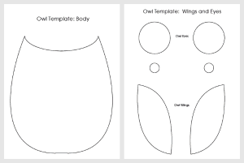Owl Body Template

Owl’s wings and eyes