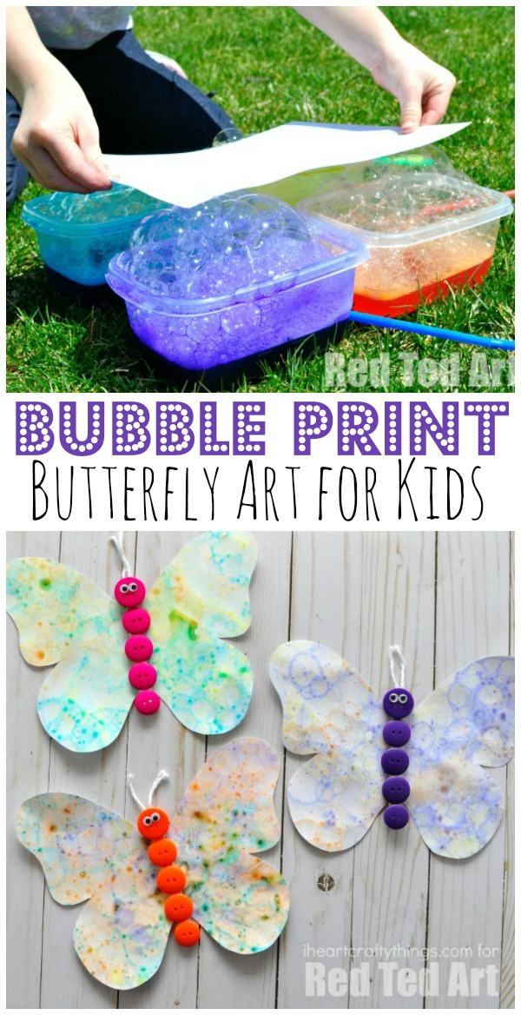

#### **Supplies you will need for your DIY bubble butterfly prints:**

* paper or watercolor paper
* bubble solution i.e. washing-up liquid and water
* liquid watercolour paints or food colouring
* small plastic containers (i.e. take away pots)
* straws

**Instructions:**

Begin by pouring bubble solution into your small containers, filling them about 1/4 full. Squirt some liquid watercolours into the containers (or food colouring) and mix the colour into the bubble solution.

Place a straw into the bubble solution and blow. You’ll notice right away that bubbles begin to form at the top of the bubble solution. Continue blowing the bubbles up and up until they overflow the container and form a big mountain. Remove your straw, grab your paper and place it gently on top of the bubbles. When you remove your paper, you can see that you’ve transferred the beautiful bubbles onto your paper. Yep making bubble paper is this easy!

Once you have left it to dry you can then cut the paper into butterfly shapes and use pompoms for the centre of the butterfly. Attach string to a straw and then the butterfly to the string and watch them float in the breeze!