Welsh Cakes
Sarah says: These are my ‘supermum’ breakfast. I sometimes make up the dough the night before ready for the kids to help roll out and cut out the cakes at breakfast time. We use all sorts of shapes too.
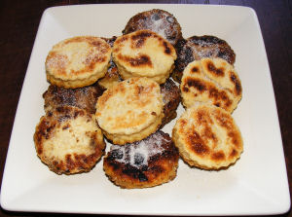
Ingredients:
200g/8oz self raising flour
100g/4oz salted butter (plus extra for cooking)
70g/2oz caster sugar (plus extra for dusting)
70g/4oz sultanas (optional)
1 beaten egg
Milk
Method:
Sieve the flour into a bowl and rub in the butter. Mix in the sugar. If you intend to make a full batch of sultana cakes mix in the dried fruit now.
Add the beaten egg. Mix to a dough, adding milk if necessary. At this point I split the dough into two and add sultanas to half the mix, but if you have less fussy children you will have either added your sultanas or be omitting the altogether.
Roll out the dough to about ½ inch thick.
Melt some butter/marg on a griddle (or frying pan). Add your cakes 5 or 6 at a time frying for 3 minutes on each side until they caramelise. You will need to add more butter between batches. Sprinkle with caster sugar while they are hot.
I like mine buttered, while the children like the plain Welsh cakes served with jam or honey.

