Hello Everyone!

We thought it would be fun to share some simple water-based play ideas, which are easy to prepare.

Most suitable equipment can be found within the home and we recommend items such as wooden spoons, old pop bottles, milk cartons, paintbrushes, rollers, measuring cups, funnels, pots, pans, muffin tins, food essence and colouring, yoghurt pots, ice cube trays and juice cartons, which are all ideal instruments for the imaginative play ideas we want to share with you below.

**PAINT AND PLAY WITH WATER**

Get outside, grab a bucket and some real house paintbrushes or rollers and paint the garden walls and fences with a bucket of water. Great fun and no mess or tidying up involved! Or just hose each other down with an old -fashioned water fight if your child will enjoy it! Hours of fun can be had filling and pouring with various containers and great for improving fine motor skills and coordination.

[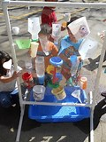](https://www.bing.com/images/search?q=decorate+with+water+play&id=3C1EF72B2CD7D172D6DBF6A9D8D26D5B14364962&FORM=IQFRBA) [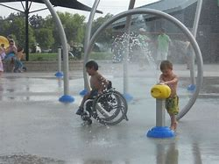](https://www.bing.com/images/search?view=detailV2&ccid=fNucQgSQ&id=D0DD88A5101389F15DC14FB784942675D9BA5D45&thid=OIP.fNucQgSQ43SGV1PYFnMW7gHaFj&mediaurl=https%3a%2f%2fi.pinimg.com%2foriginals%2fbf%2fa9%2f1d%2fbfa91de2c9c3acb3c42e37e4b7d64a0a.jpg&exph=600&expw=800&q=special+needs+children+playing+with+water&simid=608033804048402613&selectedIndex=103)

**MAKE GARDEN SOUP / PERFUME**

Pick some flowers and add to a jam jar of water, you could also add a cooking essence to give it a delicate aroma and pretend it’s a perfume. Or, if you want to get mucky, add grass and mud or soil to make garden soup and mud pies!

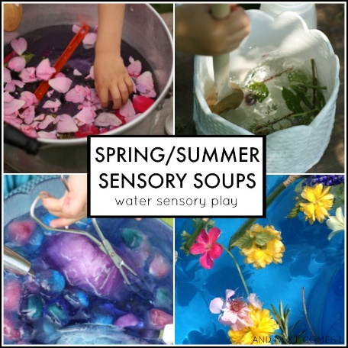 [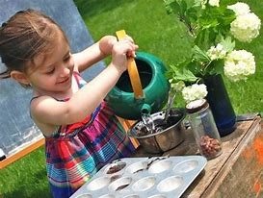](https://www.bing.com/images/search?view=detailV2&ccid=m0Q2A%2f07&id=D6929FCD93853182E26BCB1EE86BD7E6D91DB18C&thid=OIP.m0Q2A_07IBRQFf8JHo4RXQHaFp&mediaurl=http%3a%2f%2finnerchildfun.com%2fwp-content%2fuploads%2f2011%2f05%2fmudpiekitchen3.jpg&exph=381&expw=500&q=mud+soup+kids&simid=607994457864474305&selectedIndex=15)

**WASH THE TOYS**

Simple but fun! Using role-play you can involve bathing baby dolls in bubble filled washing up bowls or setting up your own car wash with various vehicles and soapy sponges.

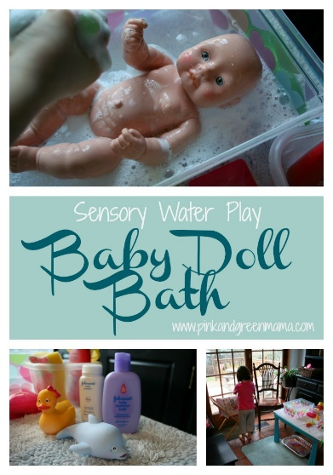 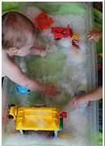 [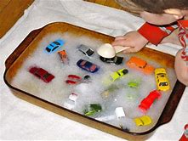](https://www.bing.com/images/search?view=detailV2&ccid=1s30QeJI&id=D40DFA372985A5CF0DE01829470B690F0C510A7C&thid=OIP.1s30QeJIHxieZZgWZq4TiQHaFj&mediaurl=http%3a%2f%2f2.bp.blogspot.com%2f-7rQjwKI2Q60%2fT2hDoGOC6OI%2fAAAAAAAADaA%2fDFZntuf0A-k%2fs400%2fIMG_3709.JPG&exph=300&expw=400&q=water+play+car+wash&simid=608037798353571271&selectedIndex=33)

**WATER EXPERIMENTS**

Fill up plastic bottles with water and add a few drops of food colouring. Watch the colours magically appear. Add glitter or flowers to your bottles with a drop of baby oil to make sensory bottles (remember to seal the lids!).

Another idea is to freeze some ice cubes using squash of various colours, put them on a white plate in the sunshine and watch the colours melt and mix together. Non-toxic and edible too for little fingers to explore and taste! Or stick a lollipop stick in and paint with them!

Also, various toys or objects can be used in a tub to explore the concepts of sinking and floating.

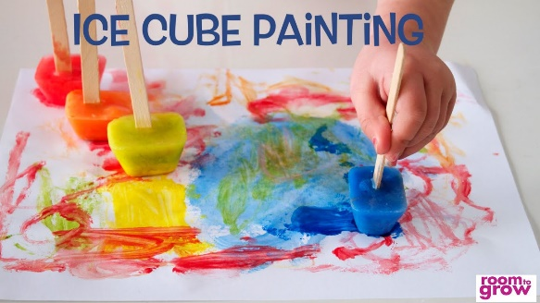 [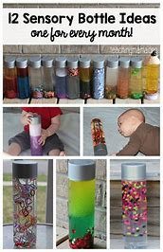](https://www.bing.com/images/search?view=detailV2&ccid=onUphQWo&id=2AFC948A7E4BD64145E784300EFD07A408F4A672&thid=OIP.onUphQWo8u1HZdIQBrFgsQHaLa&mediaurl=https%3a%2f%2fs-media-cache-ak0.pinimg.com%2f736x%2f27%2f1f%2f54%2f271f54326f1c05014e4fb95c14361552.jpg&exph=1000&expw=649&q=sensory+bottles+for+toddlers&simid=608004843019044085&selectedIndex=21)

**FLOAT SOME BOATS**

Simple boats can be made with lunchbox sized juice boxes. Cut a triangle shaped sail from old card or a cereal packet. Use the straw to strengthen the sail and poke the sharp end into the centre of the box. Have a family boat race to see who’s boat can win in the bath!

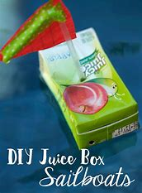 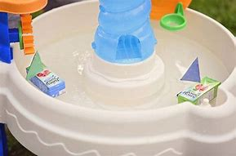

**GO FISHING**

Add ocean animals or any bath toys to a paddling pool of water and try to fish them out with a net.

[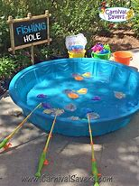](https://www.bing.com/images/search?view=detailV2&ccid=6wvyOgiT&id=E25FEF05726B7A0F476BDA8A994073B1C8652BEF&thid=OIP.6wvyOgiT1rM-39iZxpRPiQHaJ4&mediaurl=http%3a%2f%2fcdn1.bigcommerce.com%2fserver4100%2fsjl48p9%2fproduct_images%2fuploaded_images%2ffishing-pond-magnetic-carnival-game-2.jpg%3ft%3d1438345714&exph=800&expw=600&q=Fishing+Duck+Pool+Game&simid=608045013848754597&selectedIndex=18)

**DINOSAUR SWAMP**

Fill a tray or bowl with handfuls of grass, mud, branches or wood and toy dinosaurs. Make the dinosaurs jump and splash around in their swamp!

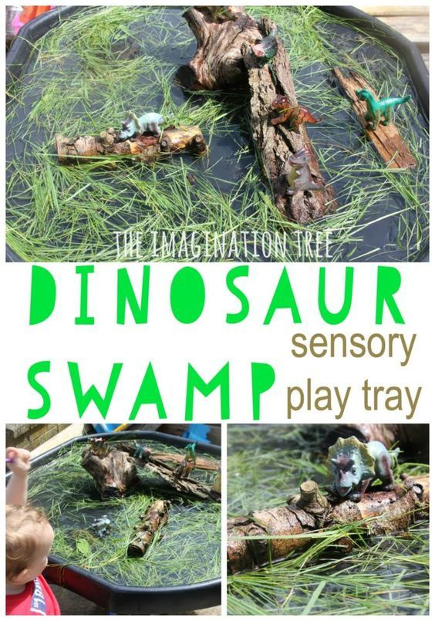

Finally, not all of our children enjoy playing with water or the sensory and tactile stimulation that it provides. If you have a child with tactile defensive behaviour then a simple sensory bag may provide enough fun for them.

OCEAN SENSORY BAG

Fill a zip lock bag with blue hair gel or some blue colouring and baby oil, glitter etc to provide the visual effect of water. Objects can be added like small shells or toy fish/sea creatures. Your child can explore and prod the bag without getting wet or sticky and no mess is involved!

[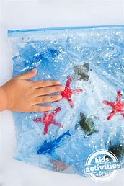](https://www.bing.com/images/search?view=detailV2&ccid=2kszc2cH&id=BF5B67ECF1BED21360600F28596CAED227ED127F&thid=OIP.2kszc2cHMJRKfUONKAckkAHaLH&mediaurl=http%3a%2f%2fkidsactivitiesblog.com%2fwp-content%2fuploads%2f2015%2f07%2fOcean-Sensory-Bag-4-copy.jpg&exph=975&expw=650&q=ocean+sensory+bag&simid=608045460521091271&selectedIndex=0) [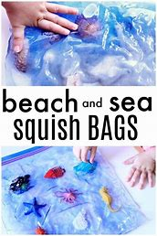](https://www.bing.com/images/search?view=detailV2&ccid=cHxRgKJ5&id=2A1158288ACF54CC2820D43B42CE0F1A4A28A93F&thid=OIP.cHxRgKJ5OrwP0kX_j_Wm0wHaLH&mediaurl=https%3a%2f%2fi.pinimg.com%2foriginals%2fc4%2f64%2fda%2fc464da8e1ff5da2aabc7c69713854449.jpg&exph=900&expw=600&q=ocean+sensory+bag&simid=607995608836801544&selectedIndex=26)

Whichever water themed activity you choose you can guarantee your child and you will have plenty of fun. Enjoy the sunshine and time you can spend playing together!