Birdhouse made from Recycled Milk Bottle

Save your empty milk bottle to create a beautiful house for your garden birds!
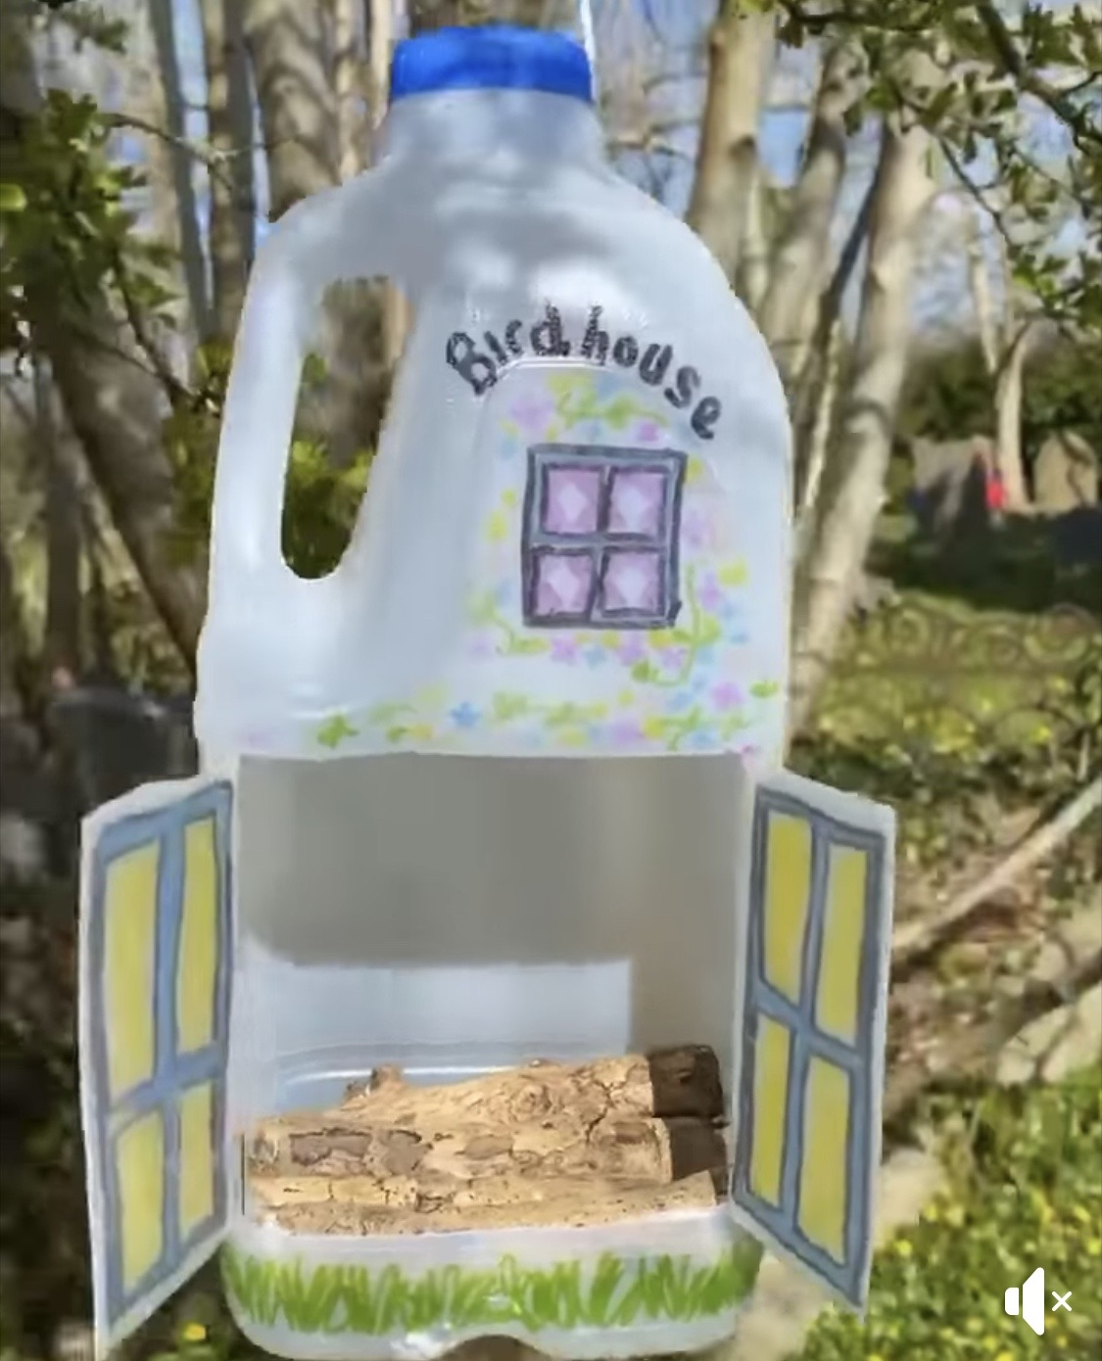
Cut two horizontal lines in the middle of your milk bottle.

Cut one vertical line in the middle and fold the two squares back to create a ‘door’ into the birdhouse.

Make sure there is enough of a gap left at the bottom of the carton to hold the twigs.

Decorate your bottle as you wish using permanent markers.

Tie a string around the top of the bottle neck and hang on a tree in the garden! You could also add some bird seed into the bottle instead in order to attract the birds.

