Counting to 5 in Welsh

To help you teach your child, this is what the numerals are called and how to pronounce them.

1 2 3 4 5

Un (een) dau (die) tri (tree) pedwar pump(pimp)

It’s time to listen to and do the actions for :

**“Clap, Clap, un, dau, tri.”** Click on the link below. Listen out for un, dau and tri.

<https://www.youtube.com/watch?v=JhxD1fXFx0c>

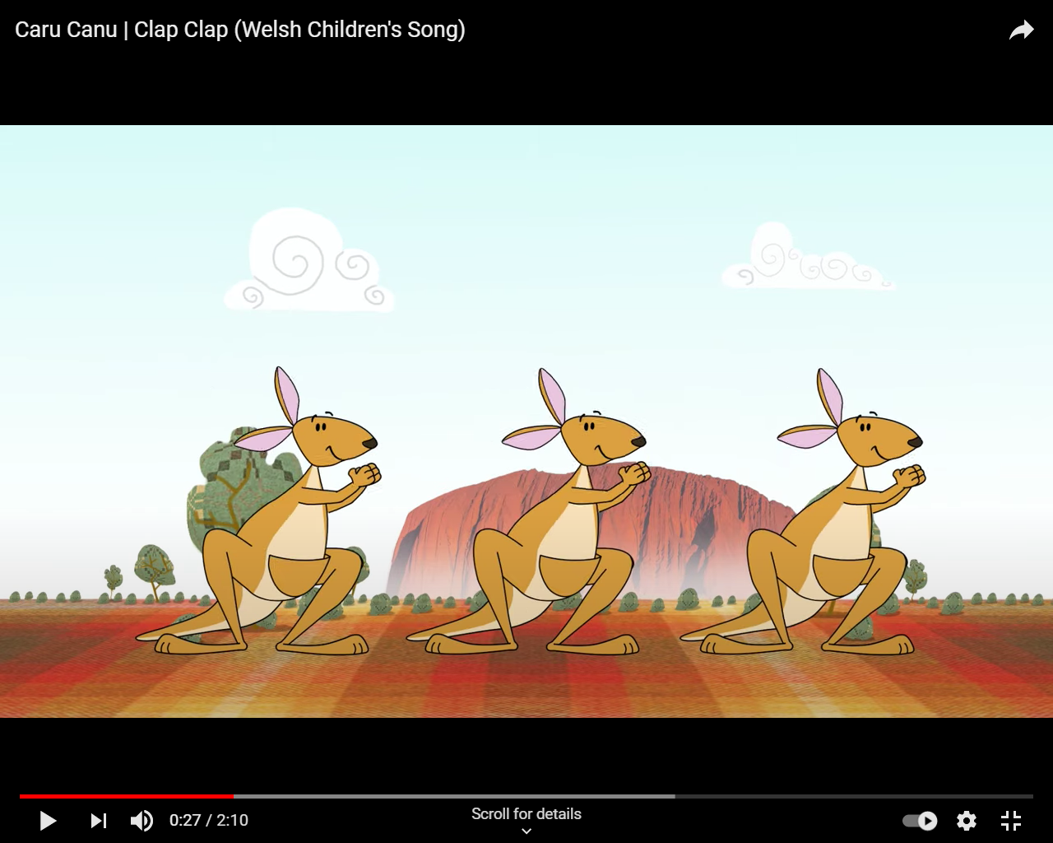

Now you can watch and listen to :

**5 Crocodeil.**

Click on the link below. Listen out for un, dau, tri, pedwar and pump.

<https://www.youtube.com/watch?v=_NtlwwGlUFI>

