The Three Little Pigs

Making the three pigs’ houses!

What you need:

Lolly pop sticks

Twigs

Rectangle shaped red paper/red paint to print with rectangle shaped sponge

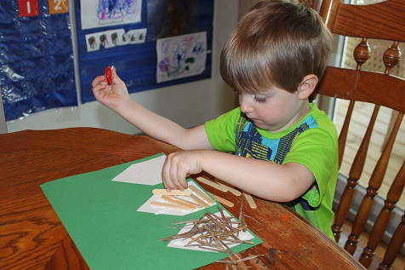White paper cut to outline of 3 houses

A3 green card

* Cut the white paper to create the shape of the 3 houses and stick to the green card.
* Glue the different materials onto each of the 3 houses.
* Use the textured feel of the houses to tell the story of the three pigs!

