**EAT THE CARROTS FINE MOTOR SKILLS GAME**

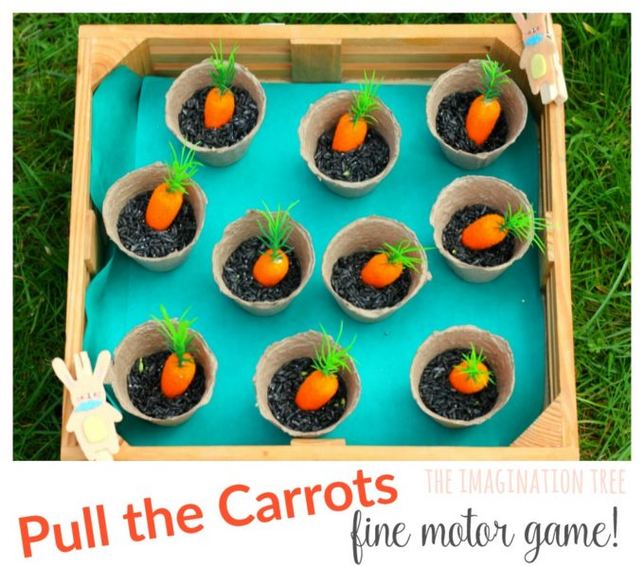Here is an adorable [**fine motor skills game for kids**](https://theimaginationtree.com/2013/09/40-fine-motor-skills-activities-for-kids.html)with this eat the carrots DIY fun tray! Simple to put together and fantastic for developing hand strength, hand- eye coordination and counting too.

**FOR THIS FINE MOTOR SKILLS GAME, YOU NEED:**

mini pots (recycled yoghurt pots)

Mini carrots

Bunny stickers

Clothes pegs/ pins

Black dyed rice

A wooden tray

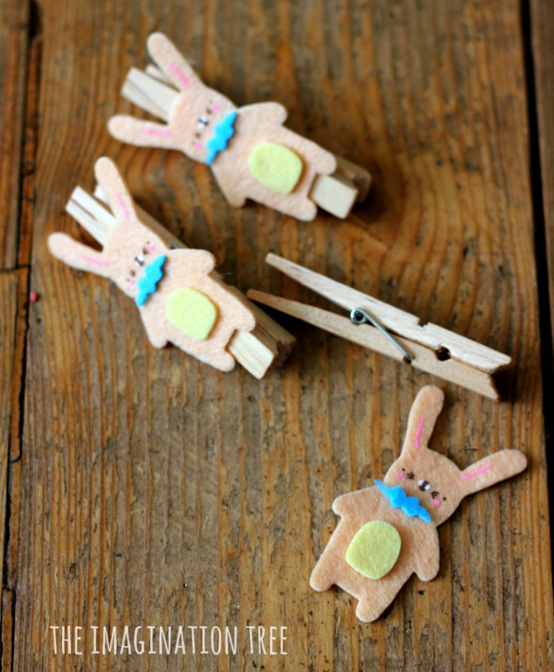

Stick the bunny stickers onto two clothes pegs to become the fine motor tool, aka the cheeky bunnies who want to eat the carrots!

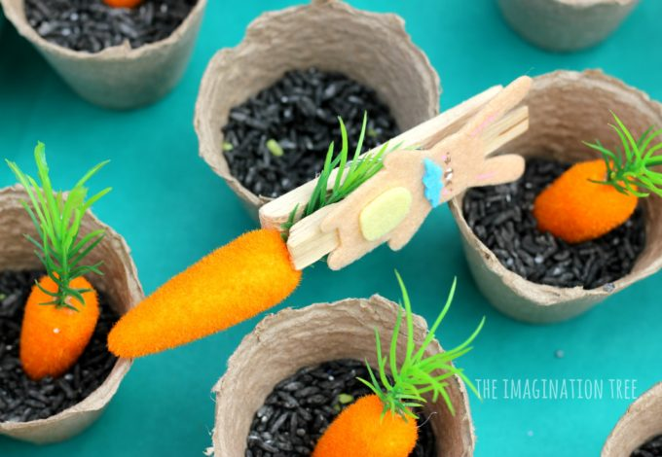

Then tip some black rice into the mini pots and added one carrot to each, setting them all into the tray which is lined with tissue paper.

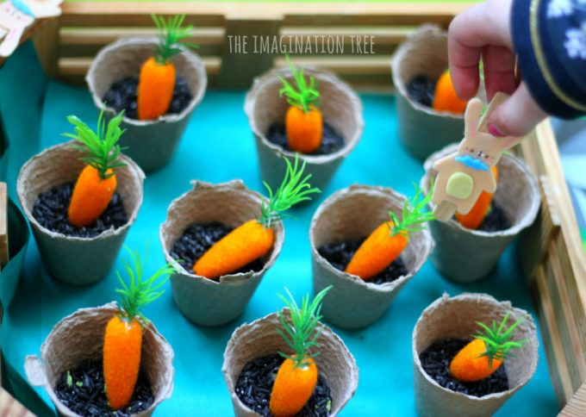

Now kids can play the bunny eats the carrots game! Pinching the peg together strengthens the small hand muscles which are important in writing and other fine motor skill development. As they play they can count aloud up to 10 and naturally learn about 1:1 correspondence.