**Bear themed sensory play**

**Teddy Bear Play Dough**

Making play dough teddy bears allows little ones to use their imaginations and build fine motor skills as they squish and stretch and mould playdough.

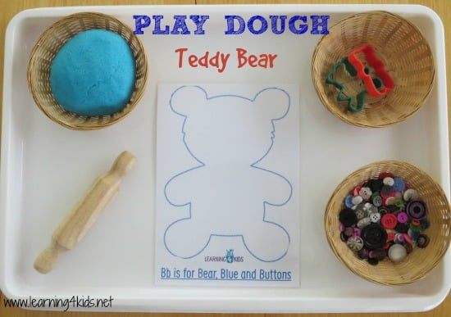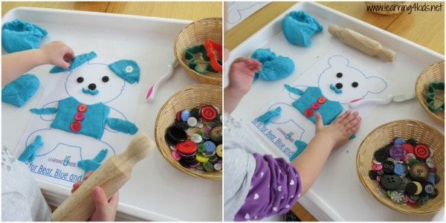

You will need play dough, a teddy template, buttons (or soft sweets), rolling pin, teddy bear cookie cutters (optional) and a child-safe play dough knife.

**SOME IDEAS:**

* Using the rolling pin, press the play dough flat and cut around the teddy bear outline.
* Make clothes for the teddy bear and add buttons.
* Create patterns with the buttons /sweets. Such as one red, one white, one red, one white, etc.
* Create textures and prints in the play dough with the knife.
* Arrange the buttons / sweets around the outline of the teddy bear.
* Sort the buttons / sweets from biggest to smallest.
* Create different types of character teddy bears, such as a happy and smiley teddy bear or a grumpy and scary one.

**Gummy Bear Slime**

* 1 cup Gummy bears
* 2 TB Cornflour
* 2 TB Icing sugar

Kids will love to smoosh, squish, stretch and taste this delicious gummy bear slime!

Microwave gummy bears in a heat-safe bowl for 10-15 seconds. Stir, and continue heating in 10-15 second intervals until gooey.

Stir in powdered sugar and cornflour in equal amounts, until the gummy bear slime forms a cohesive ball.

When your gummy bear slime is too tough to stir with a spoon, finish kneading by hand.

Add more cornflour little by little (if needed) so that slime no longer sticks to hands.

