Paper plate bird nest

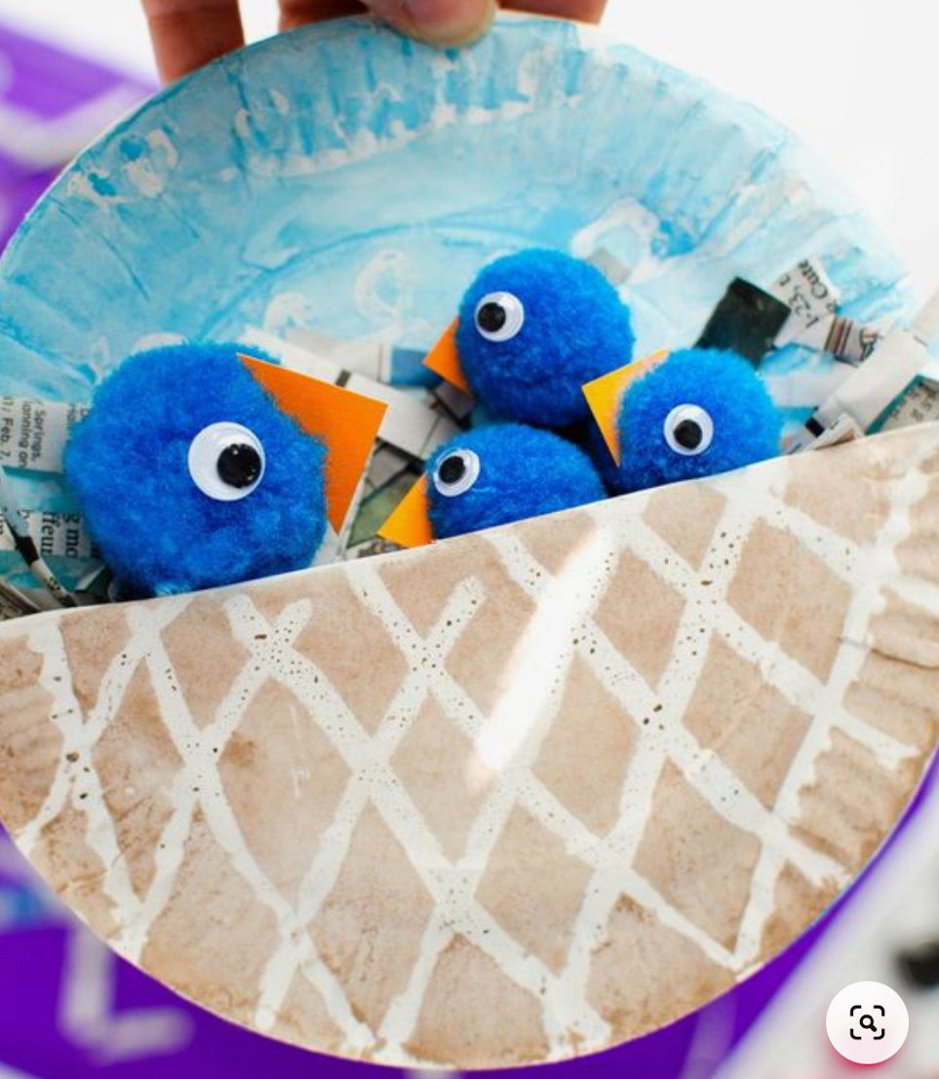
You will need:

- 2x paper plates
- Paint
- Newspaper
- Glue
- Pom poms
- Googlie eyes
- Orange card

Method:

Cut one paper plate in half and paint brown.

Paint the second whole paper plate in blue.

Stick the edges of the paper plates together with glue.

Fill the paper plate gap with shredded newspaper.

Cut small triangles from orange card and glue to pom poms.

Glue googlie eyes to pom poms.

Place into the shredded newspaper to create your own birds nest!

