We’ve got the whole world in our hands

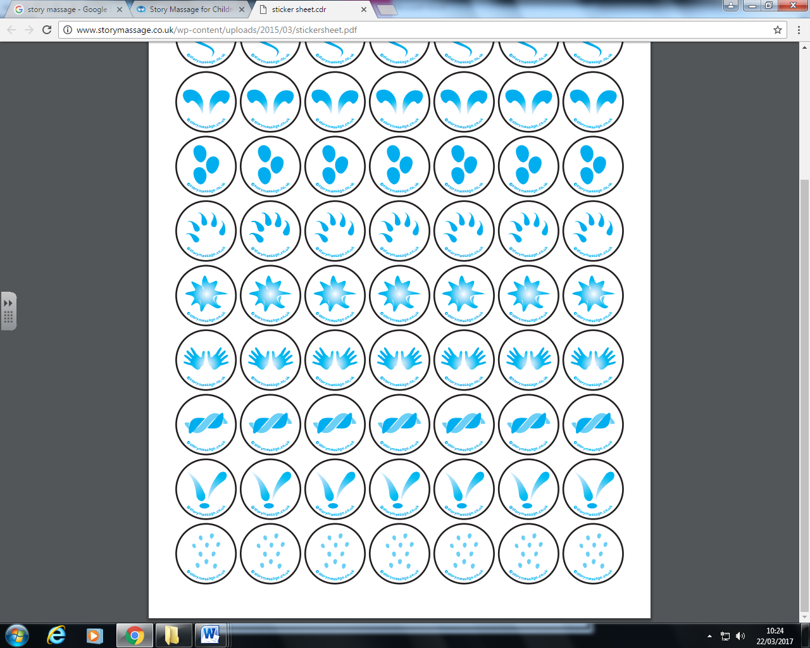



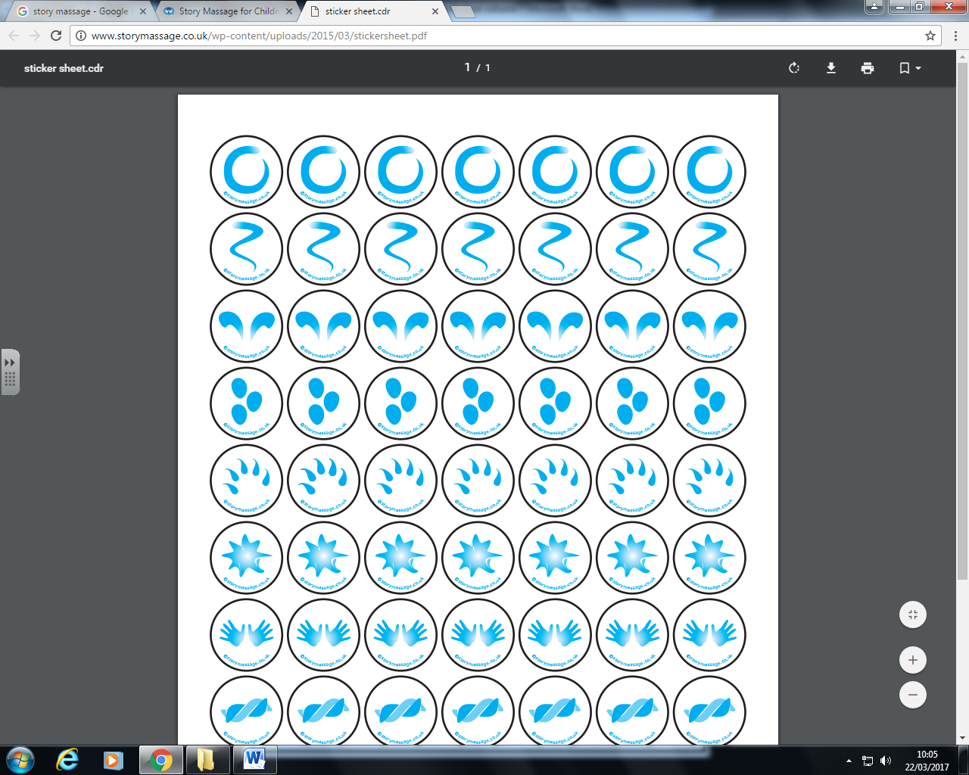









We’ve got the birds of the air in our hands x3

We’ve got the whole world in our hands

We’ve got the trees & the flowers in our hands x3

We’ve got the whole world in our hands

We’ve got the lakes and the rivers in our hands x3

We’ve got the whole world in our hands

We’ve got the plains & the deserts in our hands x3

We’ve got the whole world in our hands

We’ve got the mountains&the valleys in our hands x3

We’ve got the whole world in our hands

We’ve got the sun and the moon in our hands x3

We’ve got the whole world in our hands

We’ve got the whole world in our hands x4

**We’ve got the whole world in our hands**





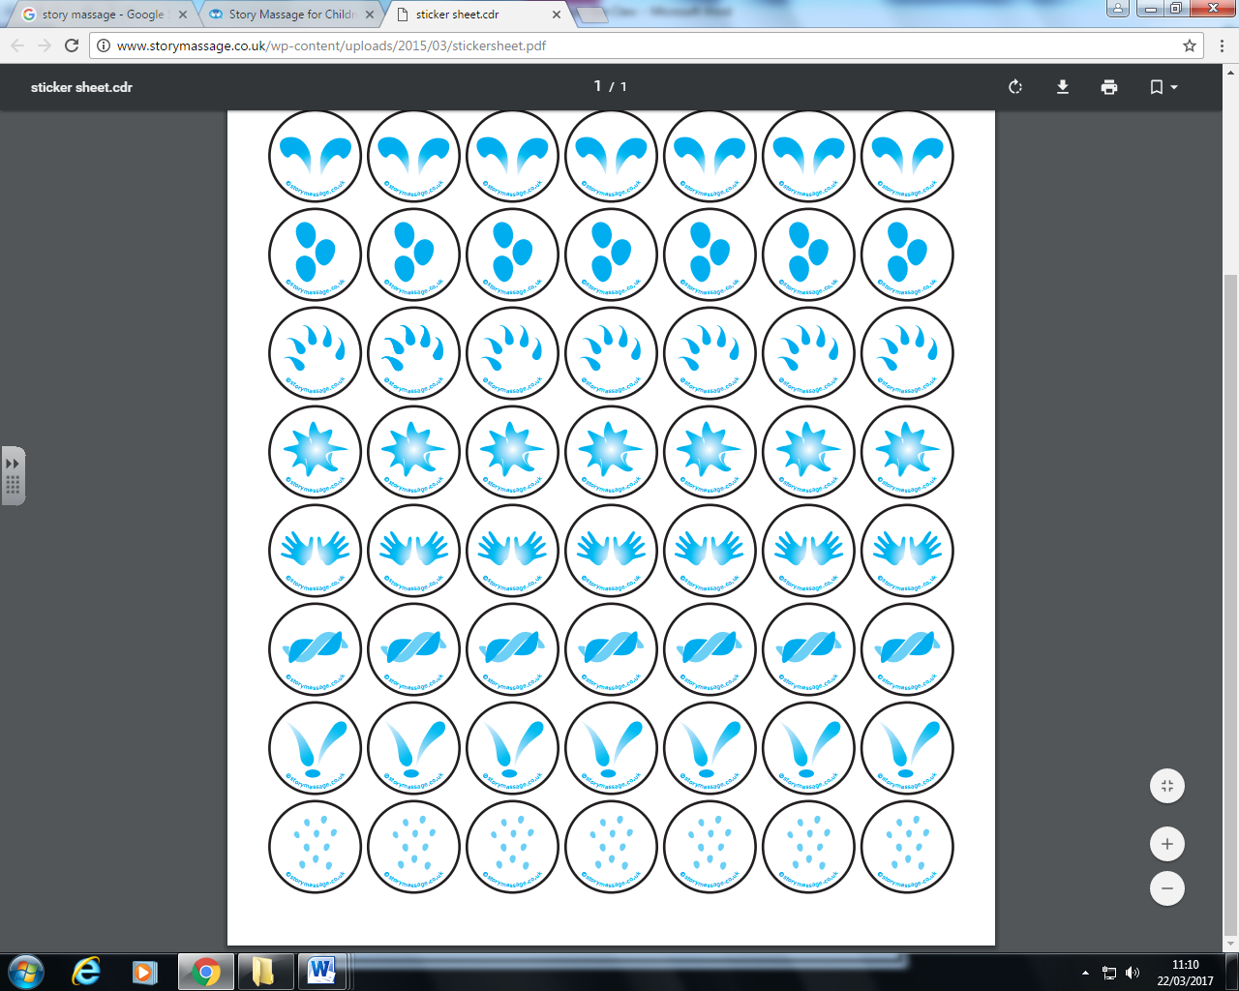

We’ve got the whole world in our hands x4

We’ve got the towns and the cities in our hands x3

We’ve got the whole world in our hands

We’ve got the fish of the sea in our hands x3

We’ve got the whole world in our hands