**Chinese Fan Art**

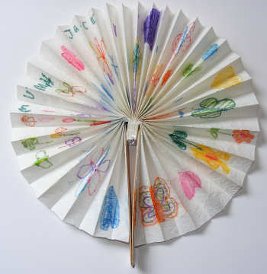

This cute Chinese fan makes a great craft for Chinese New Year or perhaps during the summer. Choose a pretty design like our butterflies, or perhaps decorate with Chinese characters for something a little more dramatic!

**You will need:**

* A piece of paper about 1m by 20cm.
* Two wide lollipop sticks
* PVA glue
* Sticky tape
* Colouring pens

Decorate your paper with the pens.

Pleat the paper into folds about 1 1/2cm wide.

Glue a lollypop stick onto each end of the paper. The lollypop sticks should stick out about 2cm above the top of the paper.

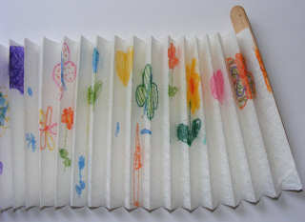

Tape the bottom of the fan together.

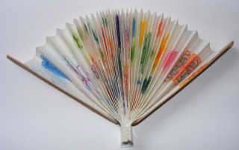

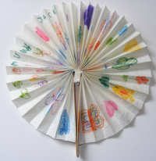 To open your fan, bring the popsicle sticks all the way round so that they meet and form a handle for you to fan yourself with! Enjoy!