Learning Opportunities in Everyday Tasks

The idea of home schooling can be overwhelming and intimidating but rest assured there is learning happening all the time and learning opportunities in activities you are doing every day. Keep up the good work.

* Opportunities to develop number skills are everywhere. You can count:- the stairs when going up to bed, places at the table, how many pieces of cutlery, how many pieces of fruit etc, the possibilities are endless.
* Add letters and numbers to play activities- for example:

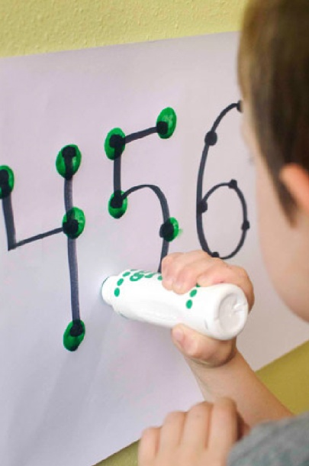

* Find the magnetic letters/numbers in messy play activities
* Write letters/numbers on building blocks
* Write letters/numbers on paper with a white crayon, when kids paint with watercolour paint the writing will appear
* Write numbers on paper, when they are using their dab pens encourage them to dab on the numbers. You could even decorate each number with as many dots as the number. Now, kids can touch each dot with their dab pen and see the number and the quantity all together.
* Bath time- pouring from one container to another, filling different vessels, squeeze out sponge, explore which items float/sink.

* Cooking - combines elements of sensory play (exploring ingredients, washing vegetables for dinner in a bowl, mixing and rolling), mathematical concepts (measuring and pouring) , home safety, and following processes. Pretend cooking, serving, and shops, are also great play scenarios teaching basic mathematical ideas as well as social interaction.
* Tidying up- support children to put similar items together , match lids to saucepans etc.

* Laundry- sorting by colour, sorting by type e.g. matching socks, big shirt / small shirt.

* Encourage independence in everyday tasks such as dressing/undressing. A way of doing this is called backward chaining. To do this start by breaking the task down into small steps. Teach your child the last step first, working backward from the goal. You complete all of the steps except the last one and have your child practice the final step.  Your child will enjoy the success that comes from completing a task. Once your child has mastered the last step you complete all of the steps except for the last two and so on until your child has mastered the whole task.
* Playtime- play is not just fun, it's important for development! Itenables children to explore and make sense of the world around them, as well as to use and develop their imagination and creativity. Set out materials to pique children’s curiosity. Sensory play can be a great way to stimulate exploration and investigation. This can be any activity which involves touch, smell, taste, sight and hearing so even a plate of jelly or some ice can offer valuable experiences. Incorporate opportunities for sharing and turn taking where possible.
* 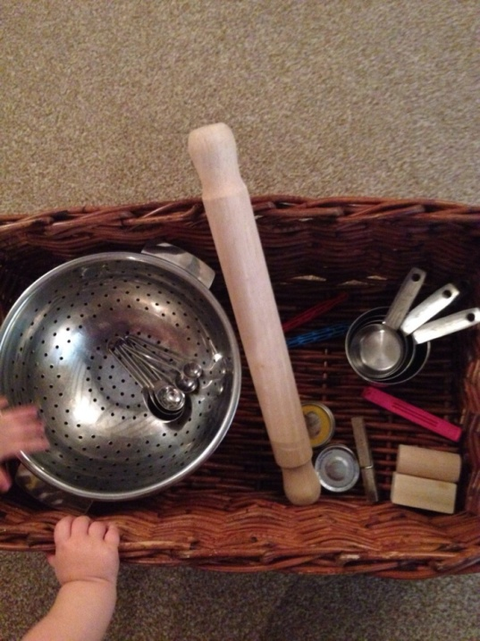Discovery basket - this is a basket that you fill with ordinary non-hazardous items for your child to explore. Children are naturally inclined to explore and investigate to develop their own understanding and knowledge. Through exploring safe items that stimulate the senses, children are storing and retaining information about texture, taste, sound, appearance and scent. Theme them for different rooms in the house e.g. kitchen basket could include: wooden spoon, colander, whisk, spatula. Bathroom basket could include: flannel, wet and dry sponges, comb, nail brush (there are lots more ideas for items here <https://thetraindriverswife.com/2014/06/23/155-items-to-include-in-your-discovery-basket/>).
* Sand play - is a fantastic opportunity for the foundations of scientific learning and physical development.
* Encourage scooping, digging, pouring and sifting.
* Playing alongside a parent or sibling it can teach about teamwork, sharing and social skills
* Use simple mathematical language, e.g. heavy, light, empty, full, big, little
* Make shapes and patterns
* Provide boxes and materials of different shapes and sizes to compare weight and quantity, how much will containers hold
* Look at the differences between wet and dry.
* When using a motivating item like bubbles make it an opportunity to practice communication. Wait for either a PECs exchange, eye contact or a physical gesture each time before blowing the bubbles.
* Reading time- develop literacy skills by showing your child that the print reads from left to right, get children to turn the page, support them to point out different things and count out items in the books e.g. how many animals are on the page, how many items are blue. Enjoy stories and rhymes with your child that have a mathematical element, e.g. “One-two, Buckle my Shoe”.
* Mark making- whether it be pen or paint or using fingers to make marks during sensory play, letting children explore paints and drawing tools allows them to experience their world in a sensory way and develop self-expression, whilst also developing pre-writing skills. Furthermore, it’s an invitation to learn about colours, mixing, and tidying up. For a less messy alternative go to the garden and paint walls with water, all you need is a paint brush, water and a wall that changes colour when it’s wet.
* Songs and nursery rhymes - sing throughout the day, using well-known songs that they may hear a lot such as ‘Head, Shoulders, Knees and Toes’ and ‘Row, Row, Row Your Boat’, will help the children memorize certain vocabulary. Singing and music hugely help to develop language and form the basis of literacy skills, as well as basic mathematical concepts such as counting. Furthermore, they begin to develop rhythm, whilst also refining their listening skills.
* Play Dough - has immense potential for learning, it teaches and improves fine motor skills, creativity, and hand-eye coordination. Threading large beads on to lengths of dried spaghetti held in the dough could add more fine motor learning to the task. Or mathematical language such as short, long, fat and thin could be used to familiarise children with these terms. Check out 'Disco Dough' on Youtube for movements to develop motor dexterity and hand-eye coordination.
* Blocks, Jigsaws, and Shape Sorters -lay the foundations of spatial thinking, logical reasoning, ordering, and recognising various shapes, sizes, and colours. Reinforce this learning by using simple colour and shape words.
* Outside Play*-* Children’s learning is emphasised when the play space is out in to the great outdoors. That’s why Forest Schools are so popular and highly regarded. Not only is it healthy, it also helps children to become more independent and inquisitive.

* Incorporate intensive interaction - Seek out opportunities throughout your daily routine to interact with your child. You can do this while bathing, cooking or sitting down at the dinner table. Let your child take the lead. Try to respond to some of the things they are doing in terms of sounds, facial expression or body movements in a fun way. You may choose to echo their sounds or mirror their posture. You could join in their actions of finger tapping, spinning on the spot or swaying from side to side and look for any reaction from them (more information on intensive interaction can be found at <https://www.intensiveinteraction.org/>).