**Mother’s Day Doughnut Bouquet**

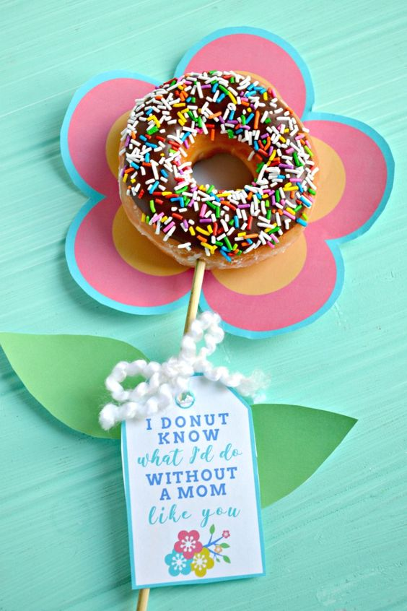

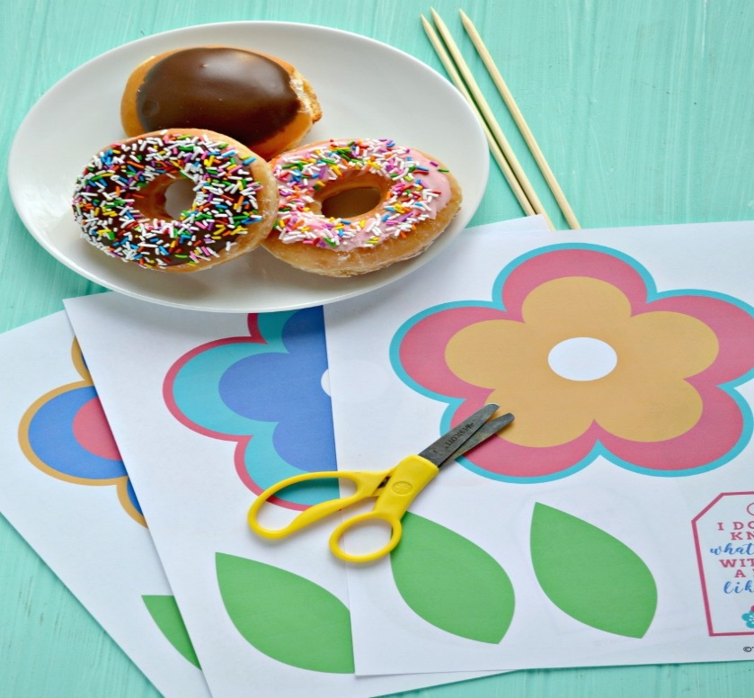You will need….

Cards to make flower and leaves (pink yellow, green and blue)

Scissors

Tape

String

Wooden Skewers

Doughnuts

**Template for flower, leaves and Mother’s Day message**

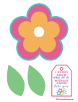

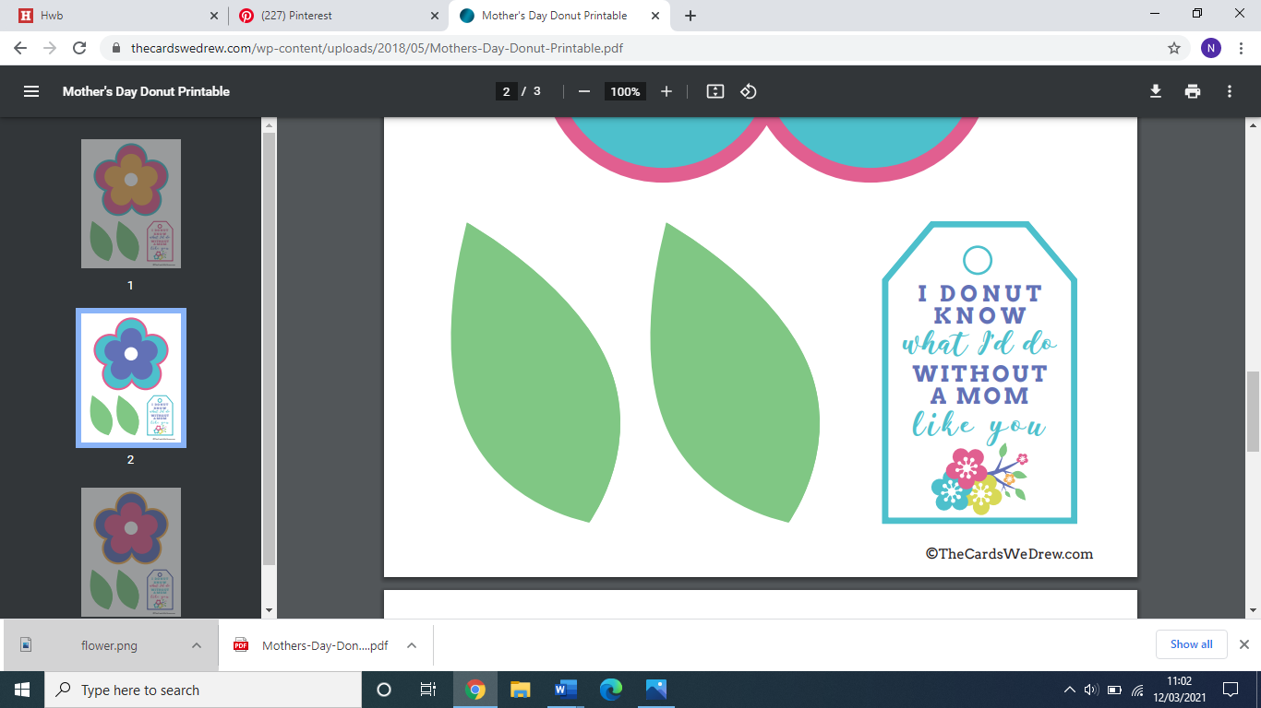

After they are cut out, you can skewer the donuts and then tape the leaves onto the “stem”. You can tie a little bow with the tag using string and set it on top of the flower. You can make this to lay flat on a platter or plate, or you could always use a little tape to adhere the flower to the stick to put it in a vase.

