HOW TO MAKE A LADYBIRD FROM EGG CARTON
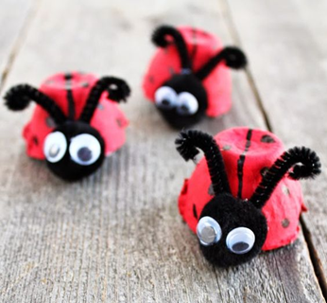
Things you need to make Ladybird:
- Egg carton
- Pipe cleaner
- Googly eyes
- Glue
- Paint (red and black)
- Black card

Take a cup from the egg carton.
Paint it red and draw some black dots and a line in the centre.
Cut a circle with black card and attach it to the front as head of the ladybird.
Stick googly eyes on the head and pipe cleaners as feelers.
Now your ladybird is ready to wiggle on your hand!

