**Spider Web Game**

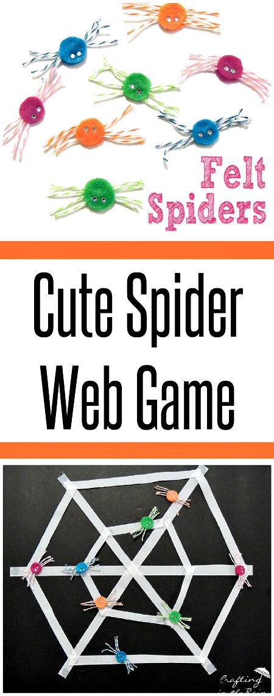

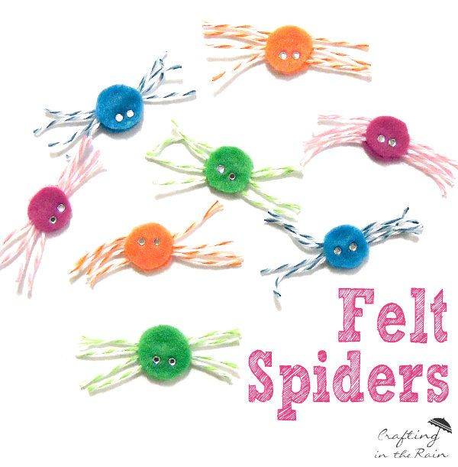First you will need a set of felt spiders.

***What you will need:***

Coloured felt

Coloured twine (or wool or other string)  
Glue gun or PVC glue  
Googly eyes (optional)

For each felt spider, cut 2 circles of felt about 3/4 inch in diameter and 4 pieces of twine about 2 inches long.

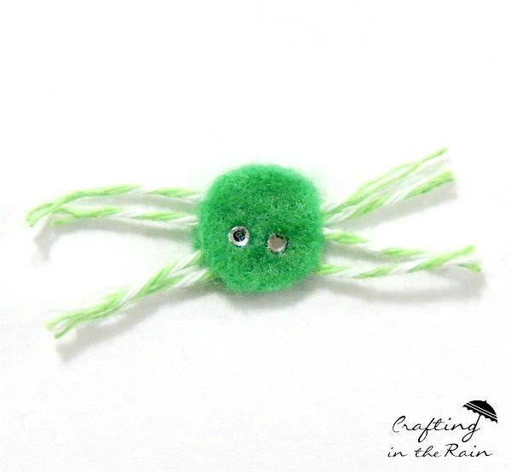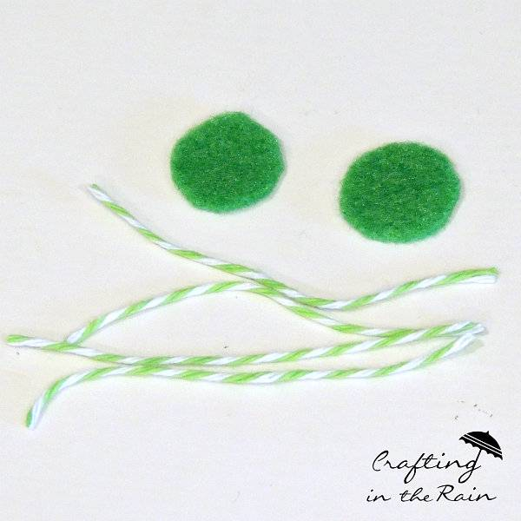

Put 4 strings in between two felts (one on top of the other) then glue them together.

To make a spider web, we need A3 size card paper or hard board (black would be perfect!) then use Velcro strips to make the shape of spider web on card paper (as shown above) and throw or stick felt spiders onto the spider web. See who can get the closest to the middle! Have fun!