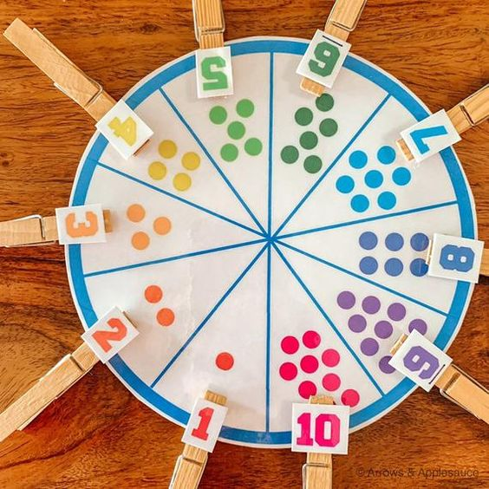**Number wheel card**

This colourful number matching game is a great learning tool for your children. Help them visually connect the written number to the number you have counted together. The clothes pegs are also a great fine motor practice! Learning to count is of course an essential building block in developing math skills, and it’s one of the first things we teach our children.

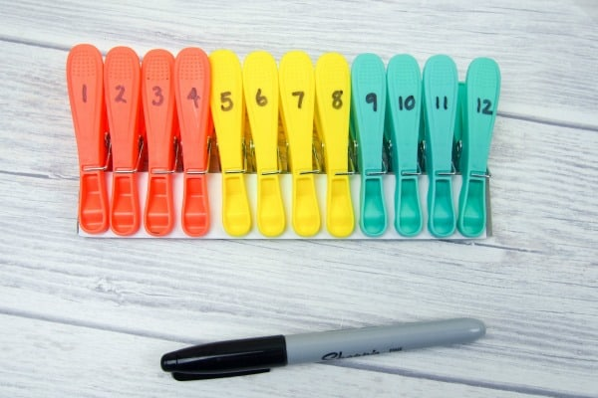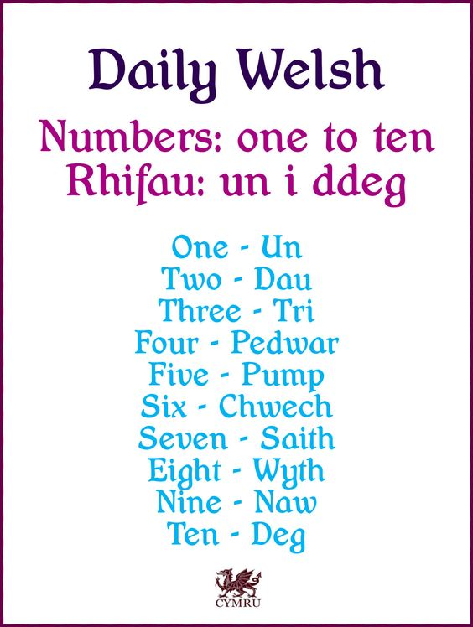

How to play

1. Print your number wheels*.* I recommend printing on card to make your wheels more durable.
2. Cut out the number wheels, laminating each one if you like.
3. Make a set of number pegs, using clothes pegs and writing a number 1 to 10 on each one using a permanent marker.
4. Set out the number pegs and the number wheels and invite your child to explore and play.

You can also count the numbers in welsh.